Barbara (Brady) Griffin
October 19, 2926 – October 4, 2009

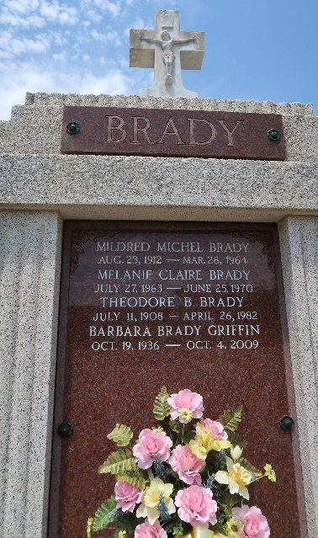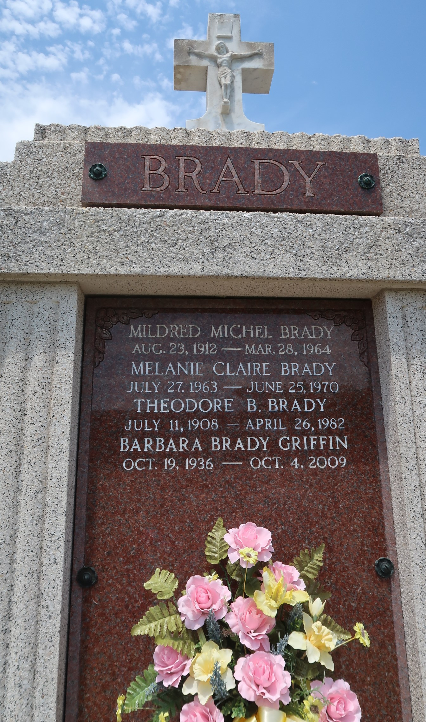

Barbara Brady Griffin passed away on Sunday, October 4, 2009 at 12:27 pm. Beloved wife of William (Bill) Griffin for 49 yrs. Daughter of the late Theodore B. and Mildred Michel Brady. Sister of Theodore B. (Teddy) Brady Jr. and wife Linda and Patricia B. (Birdie) Remondet. Aunt of her (Tooleys) Jeffrey Brady, Donna B. Moye, Stephen Brady, Angie R. King, Casey Remondet and the late Melanie Claire Brady. She is also survived by 10 Great-Nieces and Nephews.
Barbara was an active member of St. Joan of Arc Ladies Altar Society and St. Joan of Arc Thrift Shop. With this and her active involvement with LSU sports, she was blessed with many friends. Age 72. A native and resident of LaPlace.
Relatives and friends are invited to attend services. Visitation at Millet-Guidry Funeral Home, 2806 W. Airline Hwy., LaPlace, La., on Wednesday, October 7, 2009 from 9:00 am to 11:30 am. Followed by a Mass at St. Joan of Arc Catholic Church, LaPlace at 12:00 noon. Burial in St. Peter Cemetery Reserve, La. In lieu of flowers, donations preferred in her name to The American Cancer Society.

The Times-Picayune, New Orleans, Louisiana
Oct. 6, 2009

