Marie Lillian (Montz) Griffin
August 22, 1908 – March 26, 1973

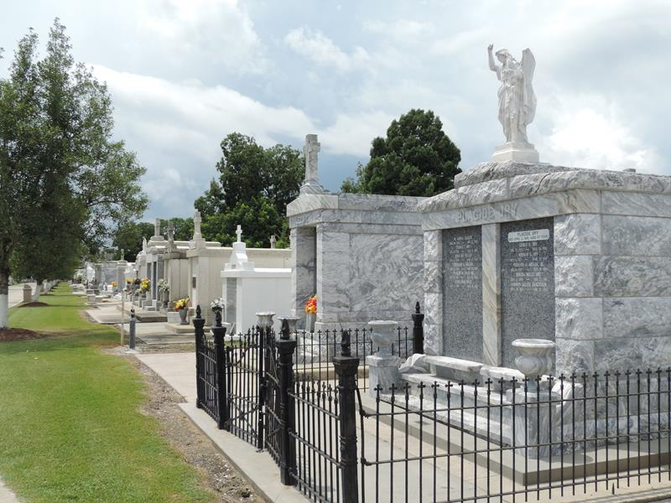

Age 64 years, a native of Lions, Louisiana, and a resident of Reserve, Louisiana. Wife of William Albert Griffin Sr, mother of William A Griffin Jr of Laplace, Louisiana, and David Lee Griffin of Reserve. Daughter of Maurice Montz and the late Virginia Cambre. Sister of Mrs. Allie (Vivian) Montz and Mrs. Alton (Yolande) Landry, both of Houston, Texas, Daniel Montz of Eunice, Louisiana, Quincy Montz of Reserve, Mrs. Earl (Pearl) Madere of Laplace and Floyd Montz of Destrehan, Louisiana.
Services were Wednesday 28 Mar 1973 at St Peter Church, Reserve, with interment in St Peter Cemetery.
The Times-Picayune, New Orleans, Louisiana
March 27, 1973

