William Albert Griffin Jr.

March 4, 1935 – February 28, 2010

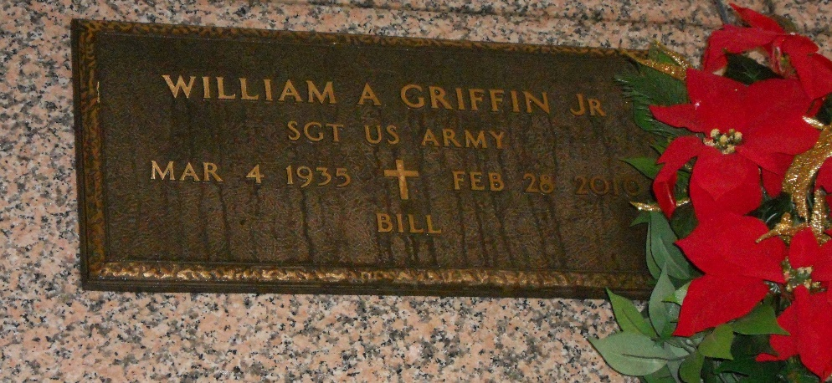

Photo by Team T-Lo

William (Bill) Griffin Jr. passed away on Sunday, February 28, 2010. Beloved husband of the late Barbara Brady Griffin. Son of the late William Sr. and Lillian Montz Griffin. Brother of the late David Griffin. Brother-in-law of Theodore Brady, Patricia (Birdie) Remondet, Lola Griffin and Linda Brady. Also survived by nieces and nephews. Age 74. A native of Reserve and a resident of LaPlace for 50 years.

Relatives and friends, also members of the St. Joan of Arc Choir and employees of Dupont are invited to attend services. Visitation at Millet-Guidry Funeral Home, 2806 W. Airline Hwy. LaPlace, La., on Thursday, March 4, 2010 from 8:00 am to 9:30 am. Followed by a Mass at St. Joan of Arc Catholic Church, LaPlace, La. at 9:30 am. Burial in St. Peter Cemetery, Reserve, La.

The Times-Picayune, New Orleans, Louisiana

March 2, 2010