William Albert Griffin Sr.
September 3, 1899 – October 1, 1976

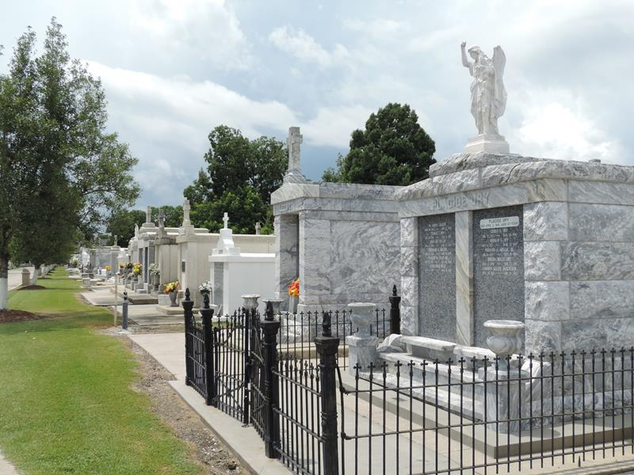
Photo by Team T-Lo

Albert Griffin Sr died Friday 1 Oct 1976 at 3:00 am at age 77 years. He was a native of Gonzales, Louisiana, and a resident of Laplace, Louisiana, for the past 3 years.

He was the husband of the late Mrs. Marie Lillian Montz Griffin and the father of William A Griffin Jr. of Laplace and David L Griffin of Reserve, Louisiana. He was the brother of the late Gilly and Edwin Griffin, Eva Leblanc. Also survived by two grandchildren.

Services were Monday, 4 Oct. 1976 at St Peter Catholic Church, Reserve, with interment in St Peter Cemetery.

The Times-Picayune, New Orleans, Louisiana
October 2, 1976

