Charles Jude Gros
November 11, 1959 – March 19, 2012

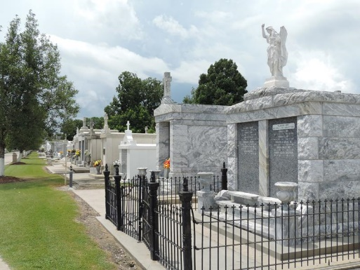
Photo by Team T-Lo

Charles “Charlie Boy” Gros, age 52, passed away on Monday, March 19, 2012 at Ochsner Medical Center. He is the son of the late Emile Gros, Jr. and Leontine Ory Gros, the sister of Lynette Gros Stubbs (Charles), brother of David Gros (Connie), James Gros (Joan) and the late Michael Gros and a number of nieces and nephews.
Visitation will be held on Wednesday, March 21, 2012 from 10:00 am until 10:30 am at H. C. Alexander Funeral Home in Norco. Graveside Services will be held at 11:00 am at St. Peter Mausoleum in Reserve, La with Fr. Terry Becnel officiating.
The family would like to express special thanks to his caregivers: Jacob Dillon, Kim Gibson, Brittney Edwards, Linda Simmons, Cathy Washington and the staff of the Arc of St. Charles for their loving care and compassion.
Memorials may be made to: Arc of St. Charles, 13771 Old Spanish Trail, P. O. Box 455, Boutte, LA 70039

H. C. Alexander Funeral Home, Norco, Louisiana

