Emile Victor Gros Jr.
November 23, 1920 – June 23, 2010

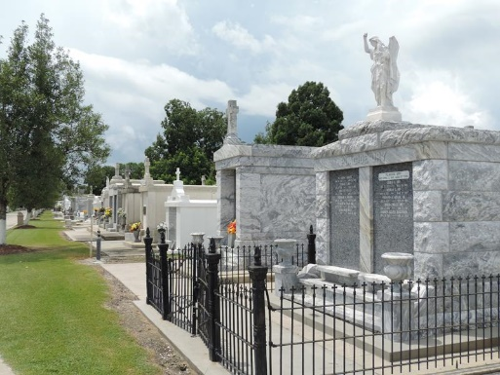
Photo by Team T-Lo

Emile Victor Gros Jr., 89, passed away on Wednesday, June 23, 2010 at the home of his daughter in Minden.
He was preceded in death by his parents, Emile Victor and Winnefred Cora Schoily Gros, his son, Michael Gerard Gros, and his sister, Audrey Gros Norton.
He is survived by his wife of 62 years, Leontine Ory Gros, children: Lynette Gros Stubbs and husband Charles of Minden, David and wife Connie of LaPlace, James and wife Joan of Abita Springs, and Charles of Hammond; eight grandchildren and eight great-grandchildren.
He was a veteran of WWII serving in the U.S. Army Air Corps and an accountant with Shell Oil Company for 30 years. The family wishes to thank Chris Harris, Pat Harris, Lilli Norton, Teresa Smith and Rosita Thomas for the love and care given to their father.
Services were held on June 28 at Alexander Funeral Home in Norco with Rev. Juliet Spencer officiating. Interment was on June 27 at St. Peter’s Cemetery in Reserve. In lieu of flowers, donations can be sent to North Lakes Support Center, home of Charles Gros, 307 Cedar, Hammond, LA.

St. Charles Herald Guide, Boutte, Louisiana
July 9, 2010

