Leontine Mae (Ory) Gros
October 6, 1917 – August 26, 2011

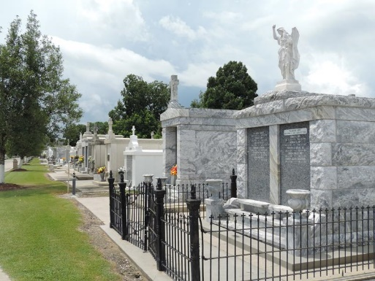
Photo by Team T-Lo

Celebratory Mass for Leontine Mae Ory Gros, 93, will be held 11:00 a.m., Saturday, September 3, 2011, at Sacred Heart of Jesus Catholic Church, Norco, Louisiana with Father Terry Becnell officiating. Entombment will follow following at St. Peters Cemetery, Reserve, Louisiana. Visitation will be held on Saturday, September 3, 2011, from 9:00 a.m. until 10:45 a.m. at Alexander Funeral Home, Norco, Louisiana.
She was born October 6, 1917, in Garyville, Louisiana, to the late Marcelin Eustach and Leonie LeBlanc Ory and passed away peacefully August 26, 2011, in Minden, Louisiana, surrounded by family. She was a dedicated member of the American Legion Ladies Auxiliary Post 195 for fifty-seven years.
She was preceded in death by her parents, her beloved husband of sixty- two years, Emile Victor Gros, Jr.; and one son, Michael Gerard Gros. Left to cherish her memory will be one daughter, Lynette Gros Stubbs and husband Charles of Minden, LA; three sons, David and wife Connie of LaPlace; James and wife Joan of Abita Springs; and Charles of Destrehan; eight grandchild-ren; and eight great-grandchildren.
Honoring her as pallbearers will be Brad Gros, David Gros, James Gros, Robert Norton, John Church and Charles Stubbs. Honorary pallbearers will be the American Legion Ladies Auxiliary Post 195.
The family would like to thank Dr. Michael Chanler, Chris Harris, Pat Harris, Lillie Norton, Erica Pitchford, Teresa Smith, and Rosita Thomas for the compassionate care provided their mother.
In lieu of flowers, donations may be sent in her memory to the Sutton Children’s Hospital, CHRISTUS Schumpert Health System Foundation, One Saint Mary Place, Shreveport, LA 71101, 318-681-6781.

H. C. Alexander Funeral Home, Norco, Louisiana

