Byron Gerard Grow Sr.
February 11, 1945– February 5, 2004

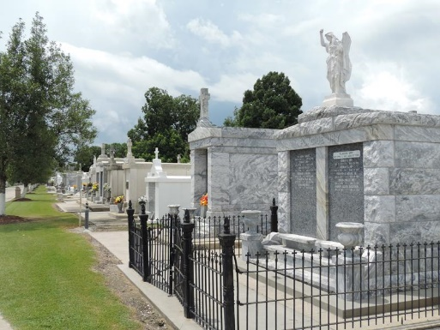

Byron G. Grow, Sr. On Thursday, February 5, 2004 At River Parishes Hospital, Laplace, La. Son Of The Late Henriette Phillips And Norbert Grow. Husband Of Dianne Thomas Grow.
Father Of Byron G. Grow, Jr., Aleshia Grow And Wendy G. Washington. Brother Of Delores Dumas, Henriette Jesse And The Late Bertacalle Batiste. Father-In-Law Of Ronnie Grow And Brian Washington. Also Survived By 4 Grandchildren And A Host Of Nieces, Nephews, Other Relatives And Friends. Age 58 Years. A Native Of Vacherie, La And A Resident Of Laplace, La.
Relatives And Friends Of The Family, Also Pastors, Officers And Members Of New Wine Christian Fellowship Church And All Neighboring Churches Are Invited To Attend The Funeral Service At New Wine Christian Fellowship Church, 1929 W. Airline Highway, Laplace, La. On Wednesday, February 11, 2004 At 10:00 Am. Rev. Neal Bernard, Pastor – Officiating. Interment St. Peter Cemetery, Reserve, La. Visitation At The Above Named Church From 9:00 Am Until Service Time. Serviced By Robottom
Times Picayune, New Orleans, Louisiana
February 10, 2004

