Mary Grace Guccione
November 18, 1911 – February 25, 2005

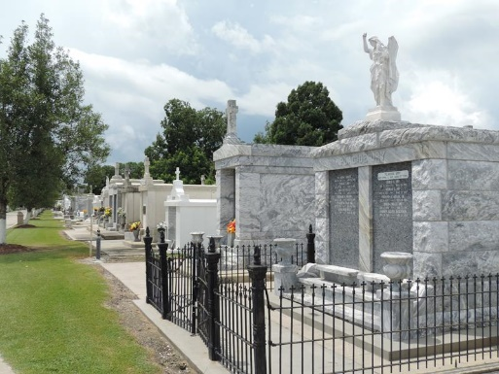

Mary Grace Guccione On Friday, February 25, 2005 At 11:41pm. Beloved Daughter Of The Late Salvadore And Congetta Panapinto Guccione. Step-daughter Of Joseph Saragusa. Sister Of Jack And Josee Saragusa And The Late Marie And Francis Guccione, Carlo, Dominick, Roy, Sam And Angelina Saragusa. Also Survived By A Host Of Nieces, Nephews, And Other Relatives. Age 89 Years. A Native Of Harvey, La. And A Resident Of St. John Parish For The Past 85 Years.
A Visitation At St. Joan Of Arc, Laplace, La On Tuesday, March 1, 2005 From 9:00 - 11:00 Am Followed By A Mass Of Christian Burial At 11:00 Am. Burial In St. Peter Cemetery, Reserve, La. Millet-Guidry Funeral Home In Charge Of Arrangements.
Times Picayune, New Orleans, Louisiana
February 27, 2005

