Cathy (Vicknair) Gueret
About 1958 – December 2, 1999
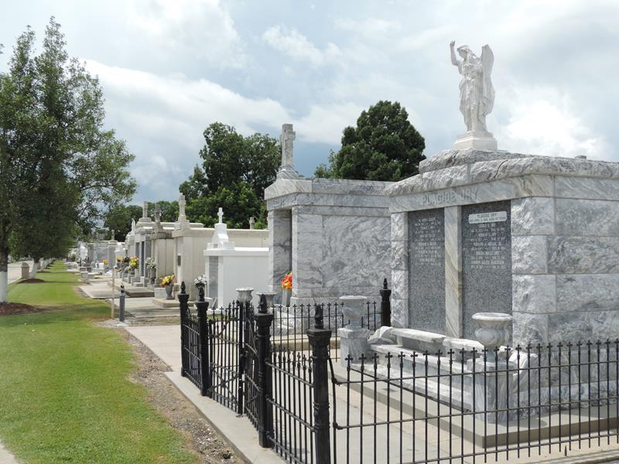

GUERET RESERVE – Cathy Vicknair Gueret, 41, a native and resident of Reserve, died Dec. 2.
She was the wife of Allen Gueret and mother of Cheryl and Tammy Gueret. She was also the daughter of Simone Vicknair and the late James Vicknair and sister of Melissa Glorioso and Pascal and James Vicknair Jr.
Services were held Dec. 6 at St. Peter Catholic Church, Reserve, with interment at the church cemetery.

L’Observateur, LaPlace, Louisiana
December 8, 1999

