Clayton P. Gueret
September 17, 1953 – August 20, 2012

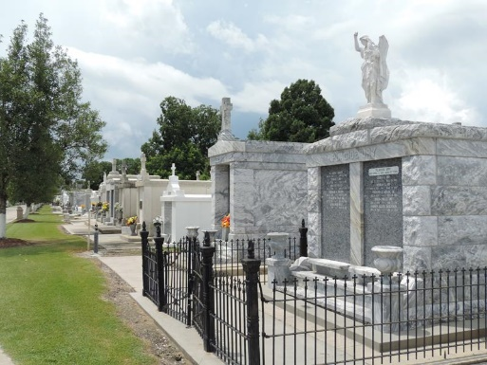

Clayton P. Gueret passed away on August 20, 2012.

Beloved son of the late Lawrence and Elsie Gueret. Brother of Brenda Gueret and the late Lawrence Jr., Ronald and Cheryl Gueret.

Services to be private at a later date.

Arrangements by Millet-Guidry Funeral Home, LaPlace, LA.
Times Picayune, New Orleans, Louisiana
August 22-23, 2012

