Earline (Champagne) Gueret
June 25, 1924 – Augusta 21, 2011

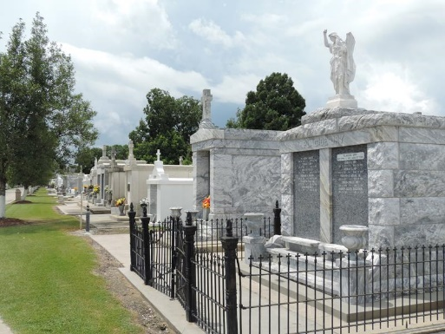

Earline Champagne Gueret passed away on Sunday, August 21, 2011.

Beloved wife of the late Joseph Gueret. Mother of the late Allen Gueret. Grandmother of Cheryl Vicknair and Tammy Reynolds. Also survived by 3 great grandchildren and 1 deceased.

Preceded in death by her parents and 5 siblings. Age 87 years. A native and resident of Reserve, LA.

Relatives and friends are invited to attend services. Visitation at Millet-Guidry Funeral Home, 2806 W. Airline Hwy., LaPlace, on Wednesday, August 24, 2011 from 8:00 AM until 10:00 AM, followed by Religious Services in the Funeral Home Chapel at 10:00 AM. Burial in St. Peter Cemetery, Reserve.
Times Picayune, New Orleans, Louisiana
August 23, 2011

