Elsie Theresa (Vicknair) Gueret
November 23, 1932 – January 19, 2010

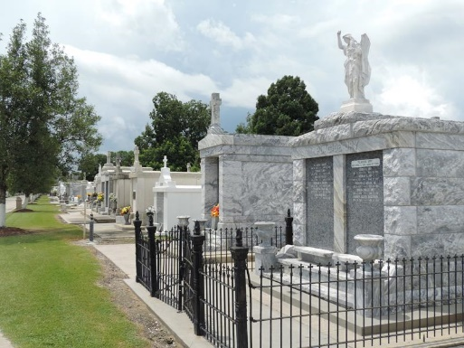

Elsie Vicknair Gueret passed away on Tuesday, January 19, 2010. Beloved wife of the late Lawrence Lee "Graton" Gueret, Sr. Mother of Clayton, Brenda, Ronald and Cheryl Gueret and the late Lawrence Lee Gueret, Jr. Sister of Celine Bardwell, Janice Stein, Verda Root, Elaine Tregre, Calvin, Lester and Adrian Vicknair. Age 77 years. A native and resident of Reserve, LA.

Relatives and friends are invited to attend services. Visitation at Millet - Guidry Funeral Home, 2806 W. Airline Hwy., LaPlace, LA, on Friday, January 22, 2010 from 11:00 AM until 1:00 PM. Followed by a Mass at the Funeral Home Chapel at 1:00 PM. Burial in St. Peter Cemetery, Reserve.
Times Picayune, New Orleans, Louisiana
January 21, 2010

