Glenn Anthony Gueret Jr.
April 26, 1985 – September 22, 2002

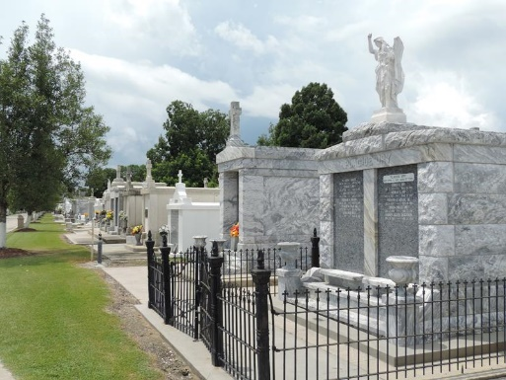

Glenn (Tony) Gueret, Jr. died in an automobile accident in Poplarville, MS. on Sunday September 22, 2002 at 7:29 A.M. Beloved son of Glenn Gueret, Sr. and Donna Landry. Brother of Brandon Landry, Angie and Amy Cambre. Grandson of Maurice A. Landry and the late Verna Landry and Charles and Winnie Gueret. Also survived by a number of aunts, uncles, nieces, nephews and cousins. Age 17 years, a native of Reserve, LA and a resident of Alabama for the past 3 years.

Relatives and friends of the family are invited to attend services. Visitation at MILLET GUIDRY FUNERAL HOME, 2806 West Airline Hwy. Laplace, LA on Tuesday, September 24, 2002 from 5:00 P.M. to 10:00 P.M. and on Wednesday from 8:00 A.M. to 10:00 A.M. Followed by religious services in the funeral home chapel. Burial in St. Peter Cemetery, Reserve, LA.
Times Picayune, New Orleans, Louisiana
September 24, 2002

