Jean Andre Gueret
June 6, 1875 – February 18, 1960

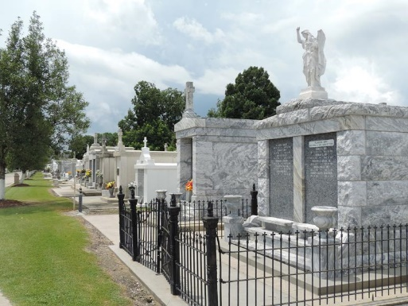

Jean Andre Gueret - Age 84 years, a native and resident of Reserve, Louisiana. Son of the late Jean Gueret and E Madere, brother of Mrs. Leonce Brady, Abraham Gueret and the late Adam Clarville and Philip Gueret.

Services were Saturday 20 Feb 1960 at St Peter Church, Reserve, with interment in St Peter Cemetery, Reserve.
Times Picayune, New Orleans, Louisiana
February 20, 1960

