Joseph Omer Gueret
April 13, 1918 - January 17, 2002

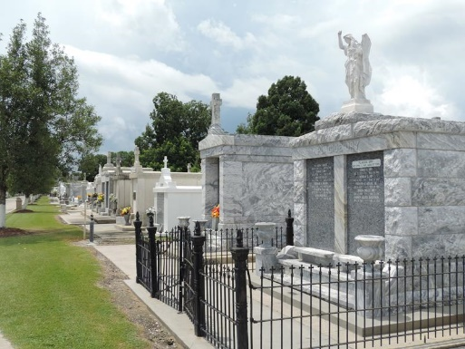

LAPLACE – Joseph Omer Gueret, 83, a native and resident of Reserve, died Jan. 17.

He was the husband of Earline Champagne Gueret and father of the late Allen Gueret. He was the brother of the late Eleanor Champagne and Antoine Gueret. He is also survived by two grandchildren and one great-grandchild.

Services were Jan. 19 St. Peter Catholic Church, Reserve, with interment at the church cemetery.
L’Observateur, LaPlace, Louisiana
Thursday, January 24, 2002

