Ann Celeste Guidry

August 11, 1915 – September 5, 2003

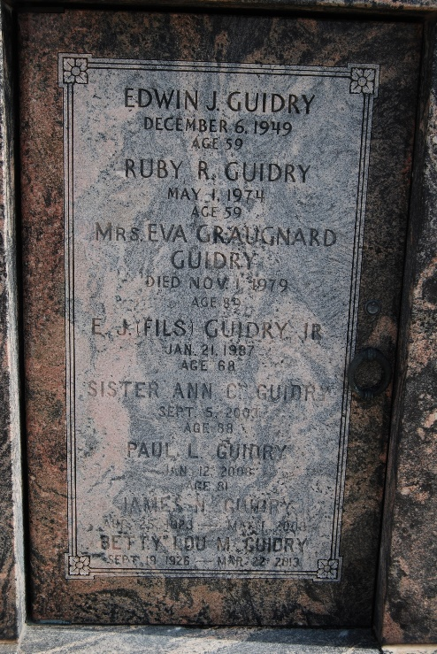 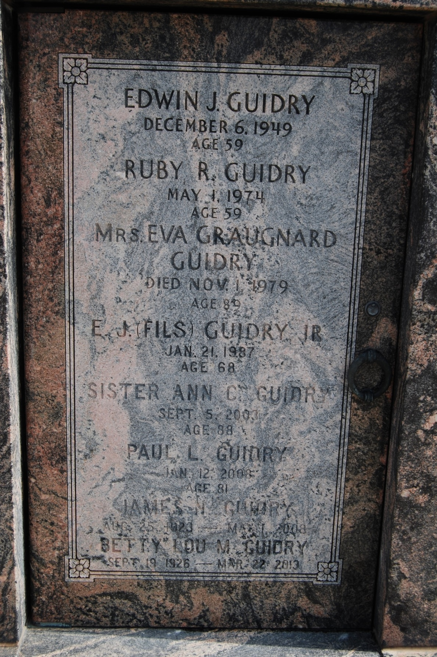

Photo by Kerry Keller

Sister Anne Celeste Guidry on Friday, September 5, 2003 at 1:00 AM. Beloved daughter of the late Edwin J. Guidry and Eva Graugnard Guidry. Sister of Mrs. Elmore (Inez) Montz of Lafayette, Mrs. E. L. (Theresa) Hotard of Lumberton, MS, Marian Guidry of Opelousas, James Guidry of LaPlace, Julian Guidry of Bogalusa, Paul Guidry of Alexandria, VA, Albert Guidry of Houma, Francis Guidry of Reserve, John Guidry of Maurepas, and the late Edwin J. Guidry, Jr. and Leon (Pap) Guidry. Also survived by 69 nieces and nephews, and numerous great nieces and nephews. Age 88, a native of Reserve and a resident of New Orleans for the past 15 years.

Relatives and friends of the family are invited to attend services. Visitation at Millet-Guidry Funeral Home, 2806 West Airline Hwy, Laplace on Sunday, September 7, 2003 from 5pm-7pm and on Monday at St. Peter Catholic Church, Reserve from 9am-10am followed by religious services at 10am. Burial in St. Peter Cemetery, Reserve.

The Times-Picayune, New Orleans, Louisiana

Sep. 6, 2003