Audrey Marie (Granier) Guidry

June 25, 1929 – December 15, 2021

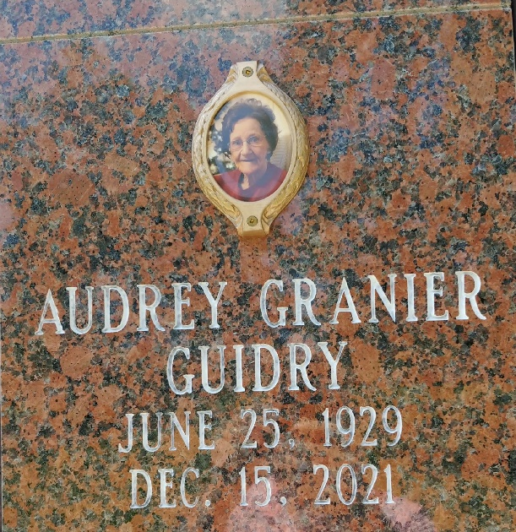

Photo by Team T-Lo

Audrey Marie Granier Guidry, of Reserve, LA, entered eternal rest on Wednesday, December 15, 2021, at the age of 92. Audrey was the youngest of nine siblings born to John Granier and Odille Michel Granier in Reserve, LA.

Audrey was preceded in death by her beloved son, Maurice Guidry; daughter, Celeste Louviere; grandson, Stanley Borne, Jr.; parents, John Granier and Odille Michel Granier; and siblings, John Granier, Maurice Granier, Theresa Granier, Margaret Acosta, Bertha Jarreau, Elvis Jarreau, Louise Vicknair and Jacqueline Delaneville.

She is survived by her daughters, Deborah Guidry Borne and Sue Bertrand; son, Julian Guidry, Jr.; grandchildren, Kevin Keating (Victoria), Nicole Jouty (Jeremy), Raymond Borne, Krissy Reno, Shannon Guidry, Jennifer Deroche (Clif), Lyndsey Qualls (Lance) and Troy Bertrand (Amanda); thirteen great-grandchildren; and one great-great grandchild.

The family extends their utmost gratitude for the compassionate care provided by Notre Dame Hospice and her caregivers, Mavis Mitchell and Barbara Maurin.

A private graveside ceremony will be at St. Peter Church Cemetery in Reserve, LA.

Millet-Guidry Funeral Home, LaPlace, Louisiana

December 17, 2021