Betty Lou (Millet) Guidry

September 19, 1926 – March 22, 2013

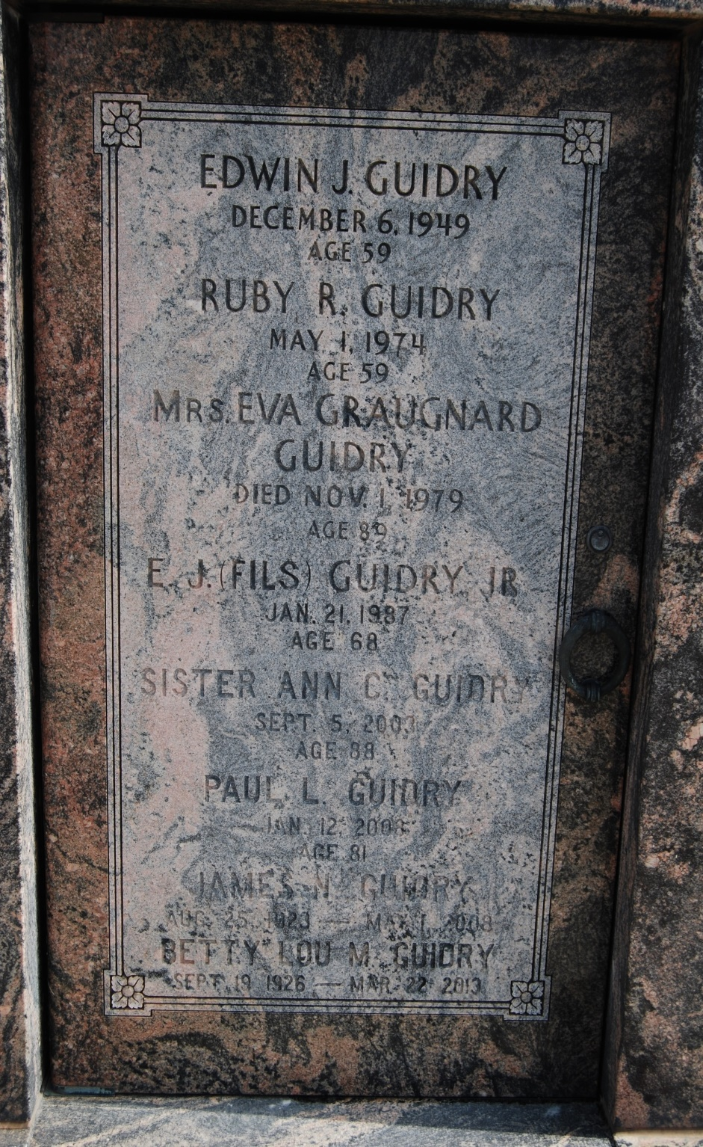

Photo by Kerry Keller

Betty Lou Millet Guidry passed away at her home in LaPlace on Friday March 22, 2012 at the age of 86. She was the beloved wife of the late James (Jimmy) N. Guidry, Sr. Loving mother of Pat Guidry, wife Barbara, Jimmy Lou Guidry Hebert, husband Clifford, Nelson Guidry, wife Elle and Jules Guidry, wife Rhonda. Mother-in-law of the late Ronnie Milioto. Grandmother of Chad Milioto, Heather Milioto Gilberti, Ryan Milioto, Jane Guidry Hood and Jim Guidry. Great-grandmother of Brennan and Julia Gilberti, Lily Milioto, Jude and Finn Hood and 4 step-great-grandchildren. Daughter of the late Jules P. Millet Sr. and Holston Moseley Millet. Sister of Carolyn Millet Ourso, H. David Millet and the late Jules (Sonny Boy) Millet Jr. A native of Garyville, LA, former resident of Reserve, LA and a resident of LaPlace, LA.

Betty Lou was a parishioner of St. Joan of Arc Catholic Church, active member of The Ladies Altar Society, Thrift Shop and a faithful member of The Michigan Card Club for 58 years.

Special thanks to her caregivers, Alice Spears, Jean Patterson, Jo Ann Bardell and Cynthia Collins.

Relatives and friends are invited to attend services. Visitation at Millet-Guidry Funeral Home, 2806 W. Airline Hwy., LaPlace, LA on Monday March 25, 2013 from 6:00pm to 9:00pm and on Tuesday from 9:00am to 10:45am, followed by Mass at St. Joan of Arc Catholic Church, 529 W. 5th St., LaPlace, LA at 11:00am. Burial in St. Peter Cemetery, Reserve, LA.

In lieu of flowers, donation preferred to The Msgr. Robert Vincent School Endowment Fund, c/o St. Joan of Arc Catholic Church, 529 W. 5th St., LaPlace, LA. 70068.

The Times-Picayune, New Orleans, Louisiana

Mar. 23 to Mar. 24, 2013