Brian Joseph Guidry

October 10, 1963 – May 28, 2004

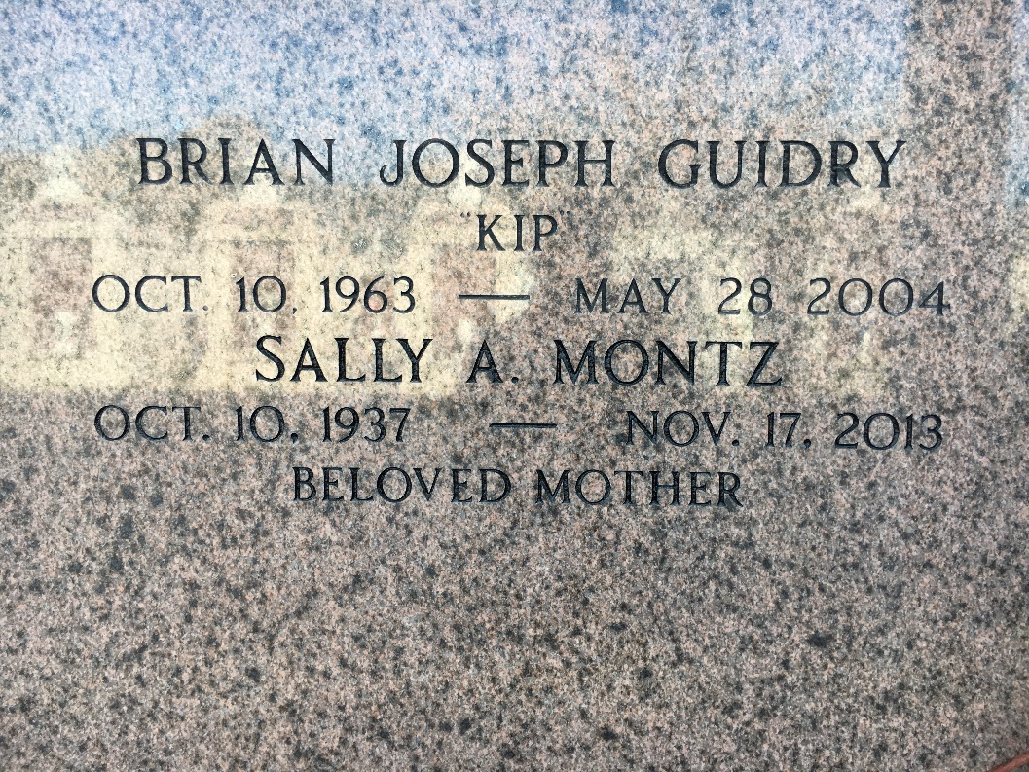

Photo by Team T-Lo

Brian Joseph (Kip) Guidry On Friday, May 28, 2004 6:54 Pm. Beloved Son Of Johnny Guidry And Sally Montz Granier. Stepson Of Jean Guidry. Father Of Danyelle Guidry. Brother Of Maria Guidry, Jane Triche, Galen And John Guidry III. Age 40; Native Of Reserve And Resident Of Hot Springs,  
Arkansas For The Past 12 Years.

Relatives And Friends Of The Family Are Invited To Attend Services. Visitation At St. Peter Catholic Church, Reserve On Saturday, June 5, 2004 From 10 Am To 11 Am. Followed By Memorial Services In The Church At 11 Am. Burial In St. Peter Cemetery, Reserve.

In Lieu Of Flowers Masses Preferred Or Donations To Get High On Life, P.O. Drawer U, Reserve, La 70084. Arrangements By Millet-Guidry Funeral Home, Laplace.

Times Picayune, New Orleans, Louisiana

June 3, 2004