Courtney Ann (Schexnayder) Guidry

September 15, 1975 – February 22, 2014

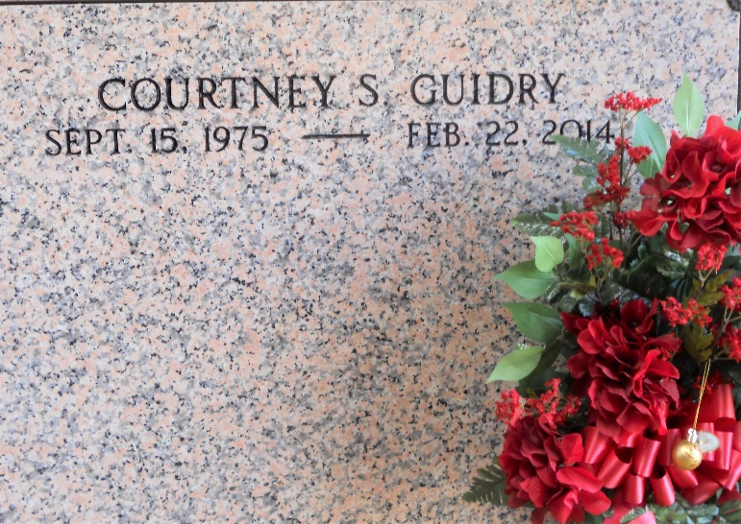

Photo by Team T-Lo

Courtney Schexnayder Guidry died on Saturday February 22, 2014. Beloved wife of Leon G. Guidry. Mother of Jude, Anna and Gabriel Guidry. Daughter of James and Linda Aucoin Schexnayder. Sister of Amanda Noel (Matt) and Josh Schexnayder (Jessica). Granddaughter of Myrtle and the late Maurice Aucoion and the late Roland Sr. and Laurence Schexnayder. Age 38. A native and resident of LaPlace, LA.

Relatives and friends are invited to attend services. Visitation at St. Joan of Arc Catholic Church, 529 W. 5th St., LaPlace, LA on Tuesday February 25, 2014 from 6:30 pm to 9:00pm and on Wednesday 9:30am to 12:00noon, followed by Mass. Burial in St. Peter Cemetery, Reserve, LA.

In lieu of flowers donations preferred to the National Shrine of Blessed Francis Xavier Seelos, 919 Josephine St. New Orleans, LA 70130.

Arrangements by Millet-Guidry Funeral Home, LaPlace, LA.

The New Orleans Advocate, Louisiana

Feb. 23 to Feb. 25, 2014