David John Guidry
November 6, 1960 – August 31, 2021

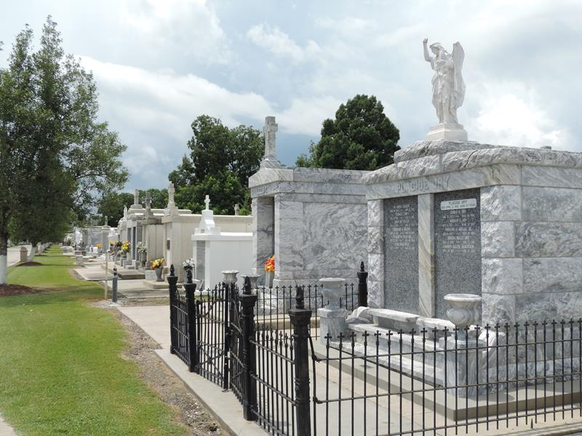
Photo by Team T-Lo

David John Guidry, a son, brother, uncle, cousin and friend, passed away on August 31, 2021 at the age of 60. He was a lifelong resident of Reserve, La. David graduated from St. Peter School in Reserve, Subiaco Academy in Subiaco, Arkansas and Delgado Community College in New Orleans.
Following graduation from Delgado, he worked as a machinist at Zen-Noh Grain Corporation in Convent. Due to a tragic accident at the age of 22, David sustained a brain injury that left him dependent upon others for all activities of daily living.
David (also known as Tootie or Duck) always had a tune in his heart. He loved to sing in the Subiaco Academy men’s chorus and could always be found tapping out a beat with his fingers. Whistling was one of his favorite past times. After his injury, he loved to engage with people and his mischievous fun nature could be seen. He will be deeply missed by all who had the privilege to know and love him.
David is survived by his mother Gertrude Guidry (Rome) and nine siblings, Leon (Richelle Lyons), Greg (Noel Fromm), Barry, Fran (Bryan Schexnayder), Chris (Jerene Bourgeois), Stephen (Kay Bourgeois), E.J., III (Susan Marse), Francis, Jr., (Maria Smith) and Michelle (Timmy Thames) and scores of nieces, nephews and cousins.
David is preceded in death by his father Francis Guidry, Sr, sister-in-law Courtney Schexnayder Guidry and his nephew Michael Thames.
The Guidry family expresses their sincere thanks for David’s caregivers Larry Alexander, Patricia Joseph, Odesa Watkins, Karen Johnson, Rose Miller and many others through the years for their kindness, compassion and professional medical care given to our beloved David.
A private graveside service will be held at St Peter Church cemetery in Reserve. In lieu of flowers, masses or memorial donations are preferred.
Memorial donations may be made to the SPS Alumni Rams Club, P.O. Box 34, Reserve, LA 70084 or Subiaco Abbey, 405 N. Subiaco Avenue, Subiaco, AR, 72865.

Rose Lynn Funeral Home, Lutcher, Louisiana

