Edward J. Guidry Sr.
July 10, 1942 – August 2, 2020

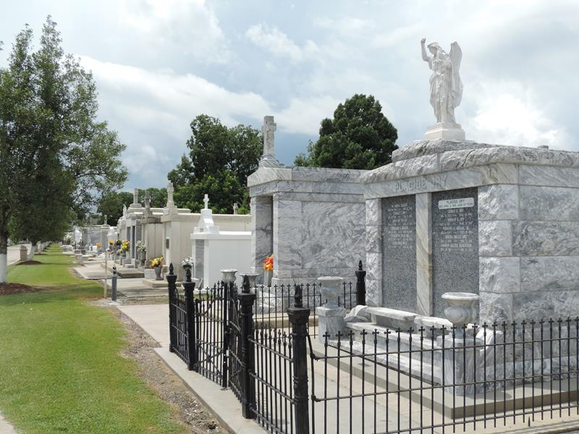

Edward J. Guidry, Sr. passed away on Sunday, August 2, 2020 at the age of 78. He was a native of New Orleans and a longtime resident of LaPlace. He was a devoted LSU and Saints fan who loved his family.
Beloved husband of Lois Arabie Guidry. Loving father of Phyllis Guidry Giamalva (the late Craig Giamalva), Edward J. Guidry, Jr. (Cindy Ervin Guidry), and the late Jane Guidry Armstrong. Son of the late Rose Mae Plaisance and Philip M. Guidry. Brother of Herbert Guidry and the late Robert Guidry. He was blessed with six grandchildren and numerous great-grandchildren.
Relatives and close friends are invited to attend the Memorial Visitation at
Millet-Guidry Funeral Home, 2806 West Airline Highway, LaPlace, LA 70068 from 10:30 a.m. until 11:00 a.m. A graveside service will follow at Saint Peter's Cemetery.

Millet-Guidry Funeral Home, LaPlace, LA
August 5, 2020

