Edwin Bernard Guidry
April 3, 1898 – November 16, 1975

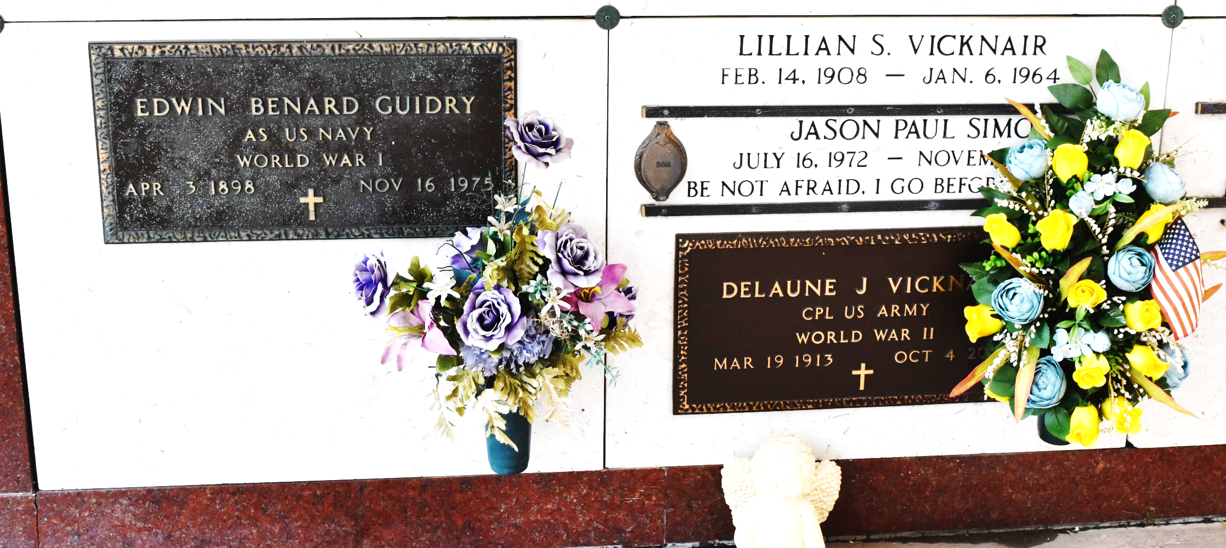

U.S., Headstone Applications for Military Veterans, 1861-1985

Name Edwin Benard Guidry
Rank A.S.
Birth Date 3 Apr 1898
Service Number 162-26-11
Service Branch US Navy
Enlistment Date 3 Sep 1918
Discharge Date 27 Dec 1918
Death Date 16 Nov 1975
Cemetery St. Peter Reserve Cemetery
Cemetery Location Reserve, Louisiana, USA

