Elle (McGoey) Guidry

September 22, 1951 – December 23, 2013

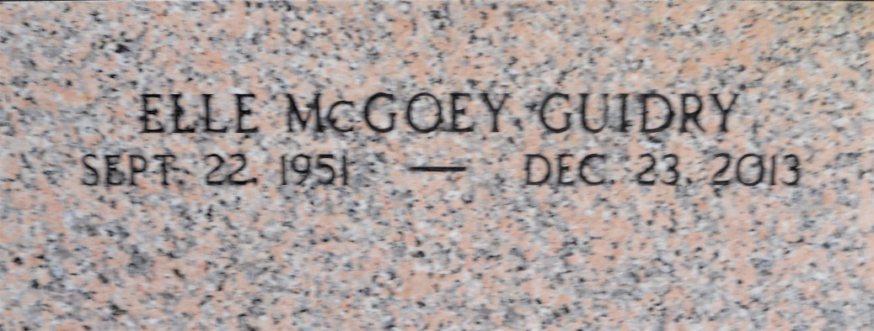

Photo by Team T-Lo

Elle McGoey Guidry died on Monday December 23, 2013. Beloved wife of Nelson Guidry. Mother of Jim Guidry. Daughter of the late John and Suzy Merrigan McGoey. Grand-daughter of the late Johnny and Rose Roddy Merrigan Morgan. Sister of Susan Sartele, Roddy, Tina and Mac McGoey. Also survived by her faithful dog Mike. Age 62. A native of Metairie, LA and resident of LaPlace, LA.

Relatives and friends are invited to attend services. Visitation at Millet-Guidry Funeral Home, 2806 W. Airline Hwy., LaPlace, LA, on Saturday, December 28, 2013 from 8:00 am to 10:30 am, followed by Mass at St. Joan of Arc Catholic, 529 W. 5th St., LaPlace, LA, at 11:00 am. Burial in St. Peter Cemetery, Reserve, LA.

In lieu of flowers, donations preferred to the Msgr. Robert Vincent School Endowment, c/o St. Joan of Arc Catholic Church, 529 W. 5th. St., LaPlace, LA 70068.

The Times-Picayune, New Orleans, Louisiana

Dec. 26 to Dec. 27, 2013