Emily Myrtle (Chenet) Guidry
October 22, 1926 – April 3, 2007

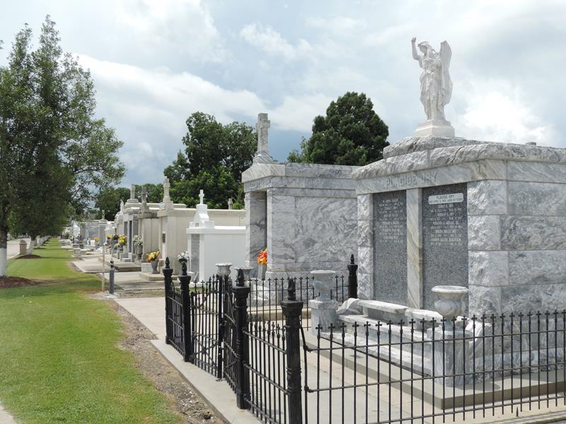

Emily Chenet Guidry On Tuesday, April 3, 2007 At 7:40 A.M. Beloved Wife Of The Alte Leon (Pap) Guidry. Daughter Of The Late Alvin And Isabelle Landry Chenet. Sister Of The Late Jennie C. Marshall. Cousin Of Joyce Henson, Sylvia Gayden And Husband, Harry, Thomas Waller And Wife, Barbara, Valerie Callahan And Husband, Pat And Jan Abreo And Husband, Leon. Age 83 Years. A Native Of Lutcher, La And A Resident Of Reserve, La For The Past 50 Years.

Relatives And Friends Of The Family, Also D.A.R., Genealogical Society And The St. James Historical Society Are Invited To Attend Services. Visitation At Millet-Guidry Funeral Home, 2806 W. Airline Hwy., Laplace, La On Sunday, April 8, 2007 From 5:00 P.M. Until 9:00 P.M. And On Monday From 8:00 A.M. Until 9:45 A.M. Followed By Religious Services At St. Peter Catholic Church, Reserve, La At 10:00 A.M. Burial In St. Joseph Cemetery, Paulina, La.
The Times-Picayune, New Orleans, Louisiana
April 5, 2007

