Eva (Graugnard) Guidry
May 27, 1890 – November 1, 1979

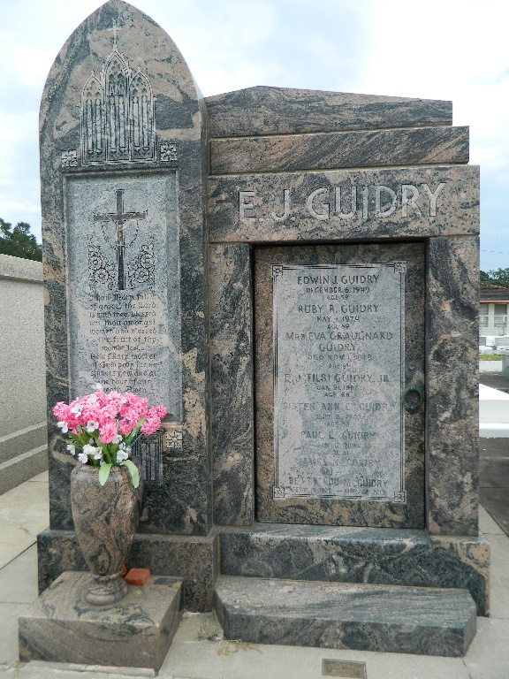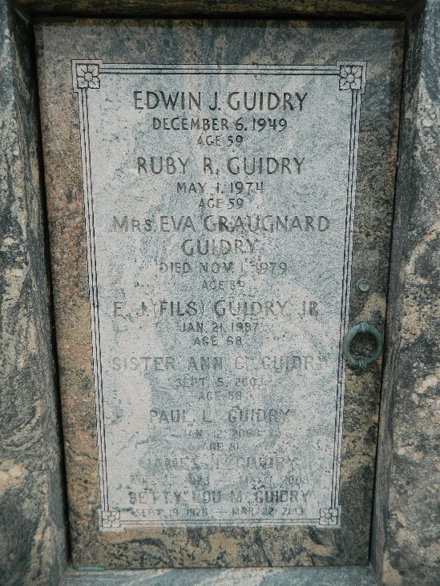

Eva Graugnard Guidry, age 89 years, died Thursday 1 Nov 1979 at 6:15 pm. She was the wife of the late Edwin J Guidry Sr and the mother of Sister Ann Celeste Guidry of Rwanda, Central Africa, Mrs. Elmore (Inez) Montz of Eunice, Louisiana, E J Jr, Leon and Francis Guidry of Reserve, Louisiana, Marion of Opelousas, Louisiana, and James of Laplace, Louisiana, Julian of Poplarville, Mississippi, Paul of Alexandria, Virginia, Albert of Houma, Louisiana and John Guidry of Metairie, Louisiana, and Mrs. E L (Theresa) Hotard of Metairie. She was the sister of Marie Graugnard and the late Emilie Graugnard and the daughter of the late Mr. and Mrs. Leon Graugnard. Also survived by 68 grandchildren and 36 great-grandchildren. She was a native and resident of Reserve.

Services were Saturday 3 Nov 1979 at St Peter Church, Reserve, with interment in St Peter Cemetery.
The Times-Picayune, New Orleans, Louisiana
November 3, 1979

