Francis W. Guidry Sr.
March 31, 1929 – March 22, 2012

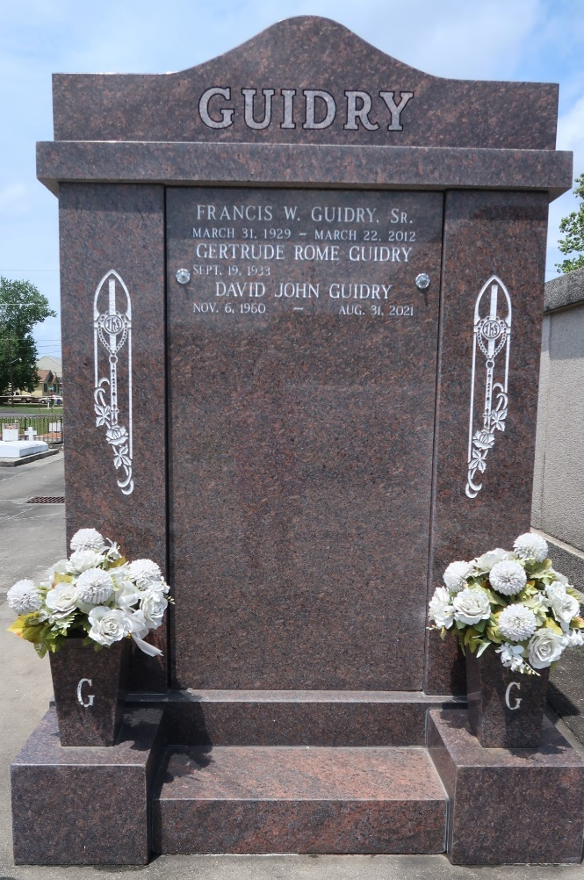

Former St. John the Baptist Parish School Board member Francis "Potat" Guidry Sr. died Thursday at the age of 82, according to his family.
Guidry, a lifelong resident of Reserve, was elected to the eighth district seat on the board in 1990, then survived a legal challenge from his opponent who alleged voter fraud to keep it. After a judge ruled in his favor, Guidry served four years. He ran again for a seat on the board in 1995, following a reshuffling of the districts, but was defeated.
Born on his family's Terre Haute Plantation in Lions, Guidry was a graduate of St. Peter Catholic School in Reserve and St. Paul's College in Covington. He served in the Korean War. He returned to Reserve, where he operated the family's now defunct sugar plantation, ran the family business and was an active member of the St. Peter Church and school community.
"He played an integral role in keeping it open a few years back," said his son, Chris. "He was a great American. He raised 10 kids who are still very active in the community. He was a caring and concerned citizen. He was very loyal to his church, to his family and was much respected by his community. He always put his best into everything he did."
Guidry won the November,1990 election for his seat, defeating Charles Maurin 685-645. Nearly a week later, Maurin challenged the results, alleging that fraudulent and illegal votes had been cast. But in December of that year Judge Marcus A. Broussard upheld the election and Guidry's victory.
Survivors include his wife of 57 years Gertrude Rome Guidry; eight sons, Francis ("Bubby") Jr., David, Stephen, Edwin III, Christopher, Barry, Gregory and Leon; two daughters, Michelle Ann Thames and Francine Noemie Schexnayder; 31 grandchildren and 12 great grandchildren.
A funeral Mass will be said Monday at 11 a.m. at St. Peter Church, 1150 River Road in Reserve. Burial will follow in St. Peter Cemetery. Visitation will be held Sunday from 6 to 9 p.m. at Millet-Guidry funeral home, located at 2806 Airline Highway, LaPlace, and on Monday from 8 a.m. until funeral time at St. Peter Church.

The Times-Picayune, New Orleans, Louisiana
March 24, 2012

