Harry Joseph Guidry

November 29, 1922 – February 22, 2001

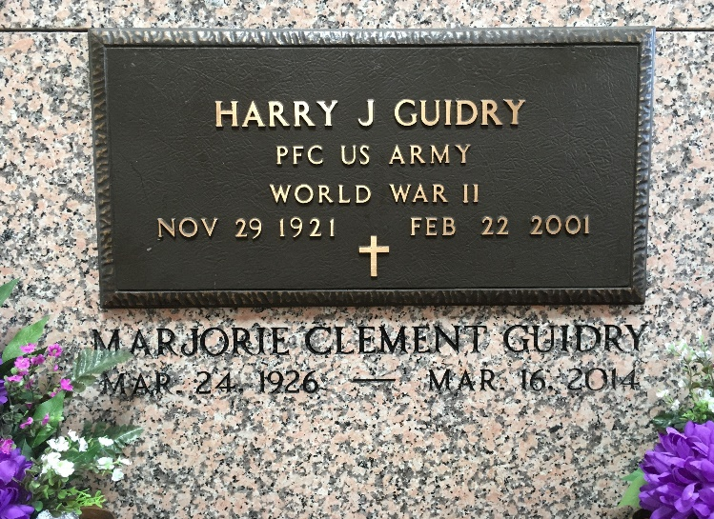

Photo by Team T-L0

Harry Joseph Guidry entered into eternal rest on Thursday 22 Feb 2001 at 6:55 p.m. at East Jefferson General Hospital. Beloved husband of Marjorie (Margie) Clement Guidry for 52 years. Father of Patti G Clement and Eva G Holmes of Laplace, Louisiana, and Ann Marie Guidry of New Orleans. Father-in-law of Clyde F Holmes. Brother of Marie A Guidry of New Orleans, Julia G Oubre of Garyville, Louisiana, and the late Richard I Guidry. Aged 79 years. A native of Braithwaite, Louisiana, former resident of Garyville, and a current resident of Norco, Louisiana.

A parishioner and usher of Sacred Heart of Jesus Church, Norco, for 50 years. Member of Sacred Heart Yard Boys, American Legion, Senior Citizens of St Charles Parish, RSVP, AARP and Shell Employees Club. He retired from Shell Oil Company in 1983.

Relatives and friends of the family, also employees and retirees of Shell Oil Company, ADM-Gromark-Reserve and Kaiser Aluminum-Gramercy are invited to attend the services. A Mass of Christian Burial will be celebrated on Monday 26 Feb 2001 at Sacred Heart of Jesus Church, Norco. Entombment in St Peter Church, Reserve, Louisiana.  
  
The Times-Picayune, New Orleans, Louisiana

February 25, 2001