James N. Guidry
August 25, 1923 – May 1, 2008

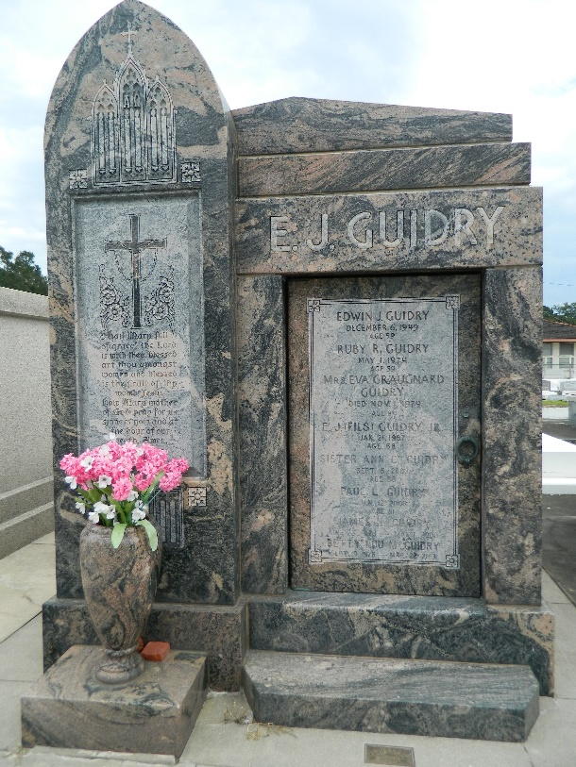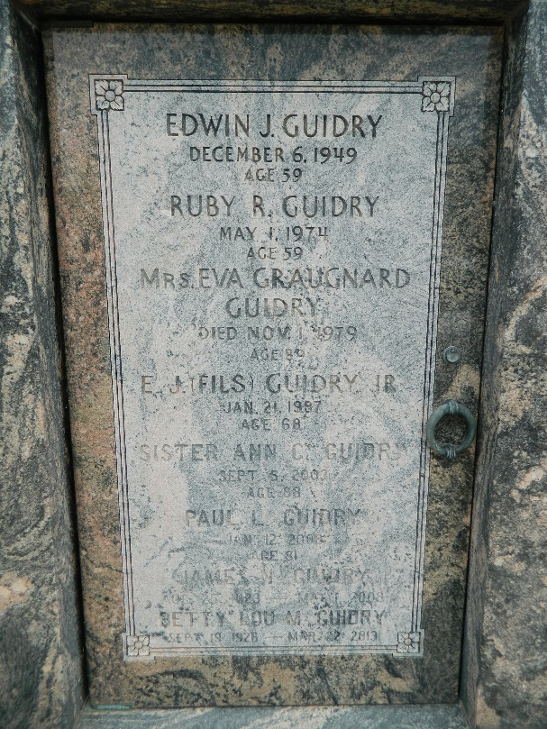

James (Jimmy) N. Guidry, Sr., age 84, on Thursday, May 1, 2008 at 8:34 p.m. at his home in LaPlace, LA. He is survived by his beloved wife of 61 years, Betty Lou Millet Guidry; and 4 children: Pat Guidry and his wife, Barbara, Jimmy Lou Guidry Hebert and her husband, Clifford, Nelson Guidry and his wife, Elle and Jules Guidry and his wife, Rhonda. He is also survived by 5 grandchildren: Chad Milioto, Heather Milioto Gilberti, Ryan Milioto, Jane Guidry and Jim Guidry; 2 great-grandchildren whom he adored: Brennan and Julia Gilberti; and 3 step-great-grandchildren. He is also survived by sisters: Inez Guidry Montz and Theresa Guidry Hotard; and brothers: Marion Guidry, Julian Guidry, Albert Guidry, Francis Guidry and John Guidry.
Preceded in death by his father, Edwin Guidry, Sr. and mother, Eva Graugnard Guidry; sister, Anne Celeste Guidry; brothers: Edwin Guidry, Jr., Leon Guidry and Paul Guidry; and son-in-law, Ronnie Milioto. A native of Lions, LA and a resident of LaPlace, LA.
Jimmy retired from Shell Chemical in 1979 after 25 years of service. He was a member of the Knights of Columbus and an active member of his church parish, St. Joan of Arc.
Relatives and friends of the family are invited to attend the services. Visitation at MILLET-GUIDRY FUNERAL HOME, 2806 W. Airline Highway, LaPlace, LA on Sunday, May 4, 2008 from 6:00 p.m. until 9:00 p.m. and on Monday from 9:00 a.m. until 10:45 a.m. Followed by Religious Services at St. Joan of Arc Catholic Church, LaPlace, LA at 11:00 a.m. Burial in St. Peter Cemetery, Reserve, LA.
In lieu of flowers, donations preferred to the Msgr. Robert Vincent School Endowment Fund, c/o St. Joan of Arc Catholic Church, 529 W. 5th Street, LaPlace, LA 70068.
Times-Picayune, The (New Orleans, Louisiana
Sunday, May 4, 2008

