Lorraine (Louque) Guidry

February 18, 1946 – April 30, 2009

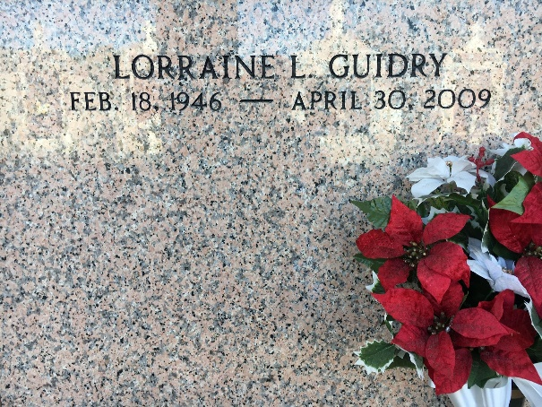

Photo by Team T-L0

Lorraine Louque Guidry on Thursday, Apr. 30, 2009 at 12:55 pm. Beloved wife of Jon Guidry. Mother of Robin Franks and husband Murry, Scott Guidry and wife Mary, Ginger and Tiffany Guidry. Grandmother of Tera Carpenter, Carley Blank, Nicole & Abigail Guidry. Daughter of the late Chester and Ethel Louque. Sister of Joan Bourgeois, Gwen Miano, Pat Trosclair, Debra Waguespack, Chester ( C.J.) Louque Jr. and Kevin (Puggy) Louque. Sister-in-law of Becky Roccaforte and Gordon Guidry. Daughter-in-law of Leon (Cat) Graugnard and the late Evelyn Graugnard. Age 63. A native of Lutcher and a resident of Reserve.

Relatives and friends are invited to attend services. Visitation at Millet-Guidry Funeral Home, 2806 W. Airline Hwy., LaPlace, La., on Sat., May 2, 2009 from 9:00 am to 11:45 am. Followed by Religious Services at St. Peter Catholic Church, Reserve, La. at 12:00 noon. Burial in St. Peter Cemetery, Reserve.  
  
The Times-Picayune, New Orleans, Louisiana

May 1, 2009