Marie A. Guidry
January 21, 1914 – August 1, 2009

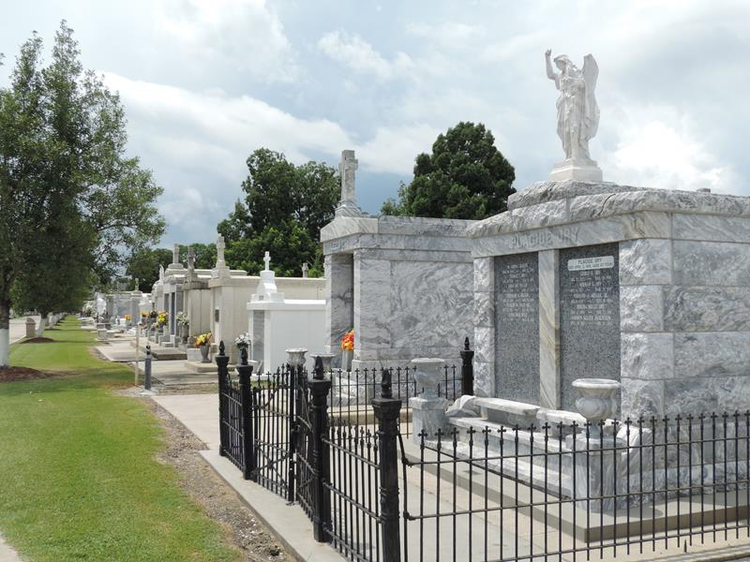

Marie A. Guidry passed away on Saturday, August 1, 2009 at the age of 93. Daughter of the late Louella Tamplain and Robert I. Guidry.
Preceded in death by her sister Julia G. Oubre, and brothers Richard I. Guidry, Sr. and Harry J. Guidry and niece Michelle Guidry.
She is survived by nine nieces: Melanie Oubre, Dayna O. Sullivan, Cheryl Guidry, Gaynell G. Jue, Arlene G. Dickerson, Adrienne G. McChesney, Patti Ann G. LeBoeuf, Eva Marie G. Phillips, and Ann Marie G. Derby; and five nephews: Stephen G. Oubre, Robert M. Guidry, Dr. Richard I. Guidry, Jr., Rene C. Guidry, and Gregory E. Guidry. A native of Garyville, LA. and long-time resident of New Orleans, LA.
Relatives and friends are invited to attend the Funeral Mass at St Hubert Catholic Church, 176 Anthony Monica St., Garyville, LA, on Tuesday, August 4, 2009 at 11:00 AM. Visitation will begin at 9:00 AM. Interment will follow in St. Peters Cemetery, Reserve, LA. To view or sign the Family Guestbook, please visit www.greenwoodfuneralhome.net.
Times Picayune, New Orleans, Louisiana
August 3-4, 2009

