Marie (Navarra) Guidry
January 26, 1914 – October 22, 2004

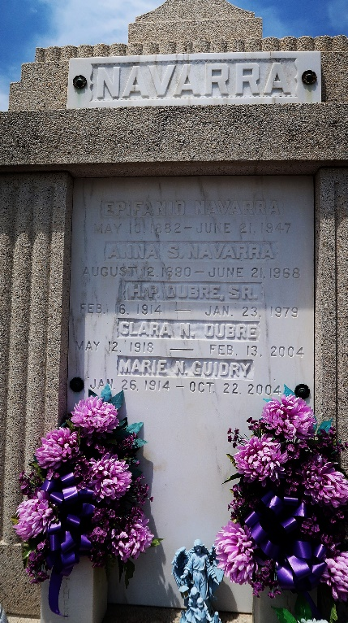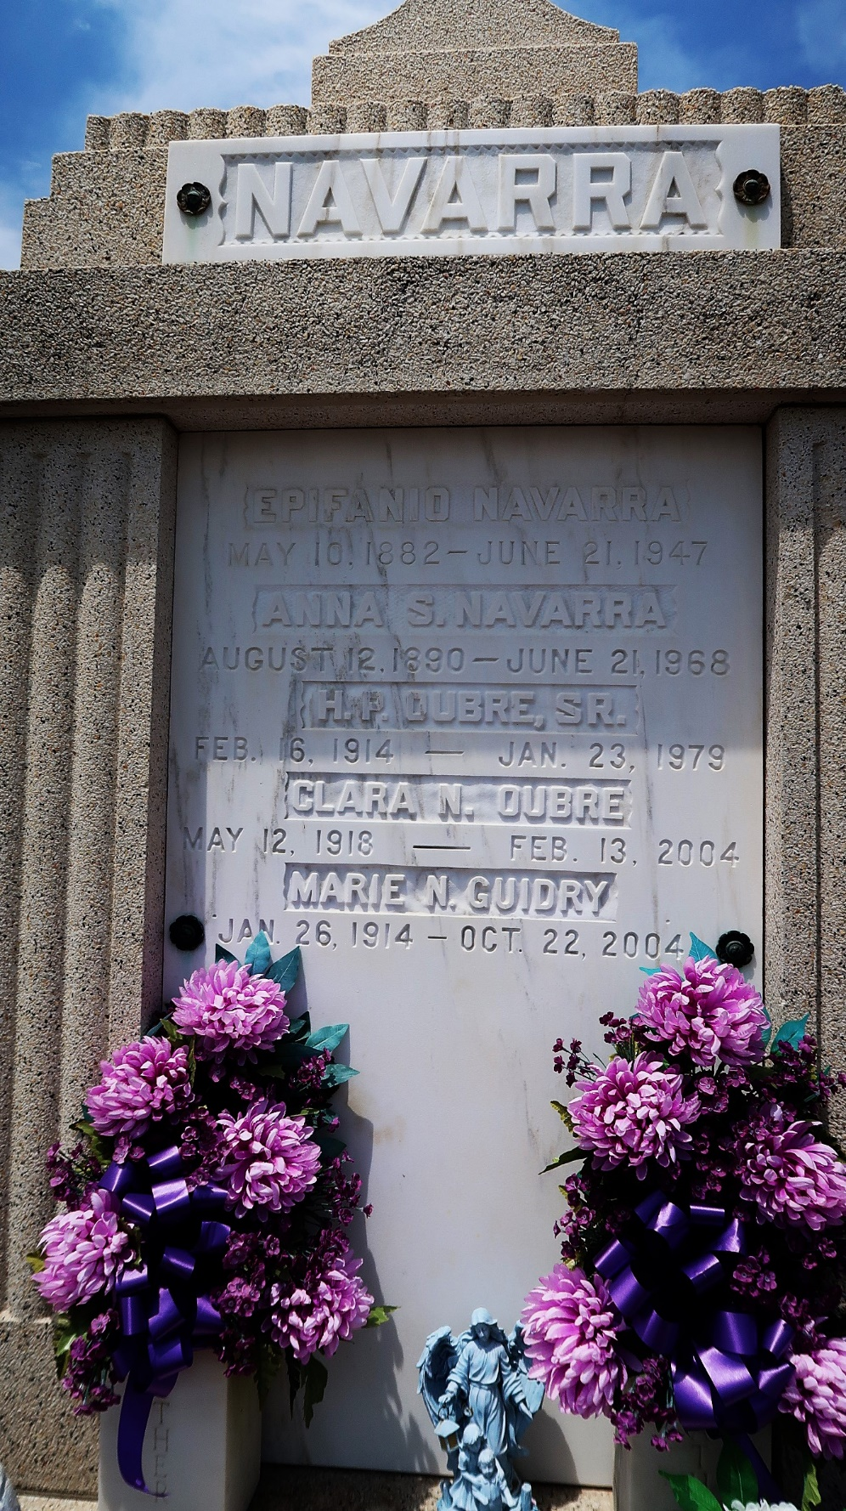

Marie Navarra Guidry On Friday, October 22, 2004 At 3:20 Am. Beloved Wife Of The Late Wilkin Guidry, Sr. Mother Of Kevin And Keith Guidry And The Late Wilkin Guidry, Jr. Daughter Of The Late Epifano And Anna Sagona Navarra. Sister Of Frances N. Falgoust And The Late Vita N. Monica, Clara N. Oubre And Catherine N. Oubre. Also Survived By 9 Grandchildren And 10 Great Grandchildren. Age 90 Years. A Native And Resident Garyville.

Relatives And Friends Of The Family And Members Of The Ladies Altar Society Are Invited To Attend Services. Visitation At St. Hubert Catholic Church Garyville On Monday, October 25, 2004 From 9am Until 12 Noon Followed By Religious Service At The Church At 12 Noon. Burial In St. Peter Cemetery Reserve. Arrangements By Millet-Guidry Funeral Home Laplace.
Times Picayune, New Orleans, Louisiana
October 23, 2004

