Marjorie (Clement) Guidry

March 24, 1926 – March 16, 2014

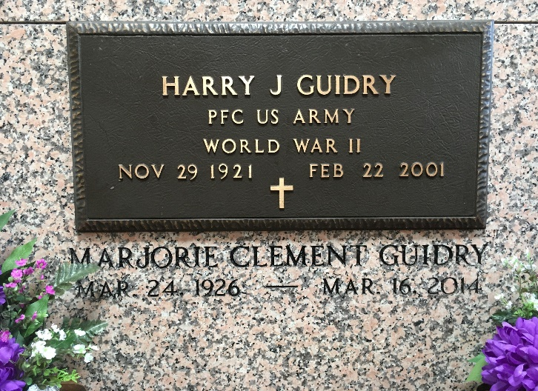

Photo by Team T-Lo

Marjorie (Margie) Clement Guidry, entered into eternal rest on Sunday, March 16, 2014, 8 days before her 88th birthday. She was the beloved wife of the late Harry Joseph Guidry for 53 years.

She is survived by three daughters and sons-in-law, Patti G. and Cecil LeBouef of LaPlace, La., Eva G. and Donald R. Phillips, Jr., of Prairieville, La., and Ann Marie G. and Mark A. Derby of New Orleans, La.; two grandchild-ren, Ava Marie and Aidan Mark Derby of New Orleans, La.

She was the daughter of the late Sidney G. Clement, Sr., and Eva Marie Montz Clement, and sister of the late Sidney G. Clement, Jr., Chester J. Clement, and Alden A. Clement.

She was a member of Sacred Heart Parish, Sacred Heart Altar Society and Holy Name Society, American Legion Auxiliary Spillway Unit 195, Norco Civic Association, AARP, Shell Norco Refinery Employees' Club, and R.S.V.P. of St. Charles. She was a dedicated volunteer at River Parishes Hospital from its inception in 1982 until mid-2010 at the age of 84. In 1996, she organized the Sacred Heart Angels of Mercy Bereavement Group and coordinated their efforts until 2011. A graduate of Leon Godchaux High School, a native of Lyons, La., and resident of Norco, La. for over 60 years.

Visitation will be held on Thursday, March 20, 2014, from 10 a.m. until 12 noon at Sacred Heart of Jesus Catholic Church in Norco. Mass of Christian Burial will be held at 12 noon. Burial will follow in St. Peter's Cemetery in Reserve, La. Condolences may be expressed at [www.hcalexanderfuneralhome.com](http://www.hcalexanderfuneralhome.com/)

The Advocate, Baton Rouge, Louisiana

Mar. 18 to Mar. 19, 2014