Mary Ann (Barrilleaux) Guidry
November 10, 1931 – July 24, 2014

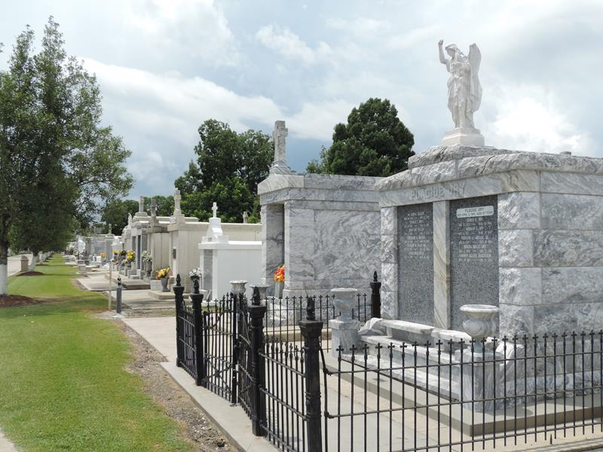

Mary Ann Barrilleaux Guidry passed away on July 24, 2018 at the age of 86. She was a homemaker and wife of the late Alvin Gerard Guidry, Sr. She was a native of Thibodaux, LA and a resident of Lutcher, LA.
Mother of: Alvin (Ada), Edward (Joan), Bonnie (deceased), Faye, and Michael (Carrie). Grandmother of: Victor (Lisa), Darrin (Kaci), Trish (Catherine), Bryce (KaNita), Jeremy, Christine (Christine T.), and Cindy (Michael). Great-grandmother of: Cody (Markie), Cassie, Caden, McKaylee, and Beaux.
Daughter of the late Marcelien Barrilleaux and Corrine Poche’. Preceded in death by sisters, Inez Ledet, Gladys Legendre, Marie Louise Naquin, and Florence Pitre; brothers, Roland Barrilleaux, Sr. and Lester Barrilleaux.
She was a past President II and co-founder of St. Vincent de Paul of Lutcher, LA.
A visitation will be held in her honor on Friday, July 27, 2018 at St. Joseph Catholic Church in Paulina, LA from 9:00 am until the Mass of Christian Burial at 11:00 am. Interment will follow in the St. Joseph Mausoleum. Online condolences can be given at www.roselynnfuneralhome.com.

Rose Lynn Funeral Home, Lutcher, Louisiana

