Miriam (Laurent) Guidry
July 25, 1928 – July 30, 2017

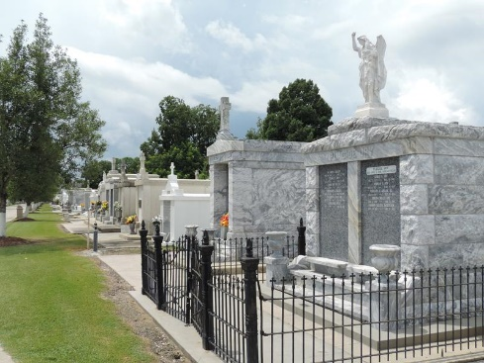

Miriam Laurent Guidry, 89, a native of Laplace and a longtime resident of Luling, passed away on July 30, 2017. Miriam is survived by her husband of 57 years, Joseph "JA" Guidry, daughter Lyndall Boyce (Bob), son Dr. Kyle Guidry (Rachel); grandchildren Madeleine and Allison Boyce, Claire and Kate Guidry, sister-in-law Audrey Guidry Miranda Friloux.
Miriam was preceded in death by her parents Ramire and Zeolide Laurent; brother Lionel Laurent and sister-in-law Anna Mae Laurent and brother-in-law Clyde Guidry.
Miriam was a devoted Catholic and a parishioner of Holy Family Catholic Church in Luling. She worked for the St. Charles Parish Clerk of Court for 35 years, and enjoyed helping people in her job. Her greatest joy was being with her children and grandchildren. She prayed the Rosary daily and was a member of the Fatima Home Rosary Group.
Special thanks to Lafourche Home for the Aged, Notre Dame Hospice, and caregivers Diane North and Beryl Trepino for their kindness and compassion during her illness.
A Mass of Christian Burial will be celebrated at Holy Family Catholic Church in Luling, LA on Thursday, August 3, 2017 at 11 AM. Visitation will begin at 9 AM. Burial to follow Mass in St. Peter's Cemetery in Reserve, LA. In lieu of flowers, Masses preferred. H.C. Alexander Funeral Home in charge of Arrangements.

The Times-Picayune, New Orleans, Louisiana
Aug. 1 to Aug. 4, 2017

