Philomene Aurore (Scioneaux) Guidry
October 7, 1869 – August 14, 1960

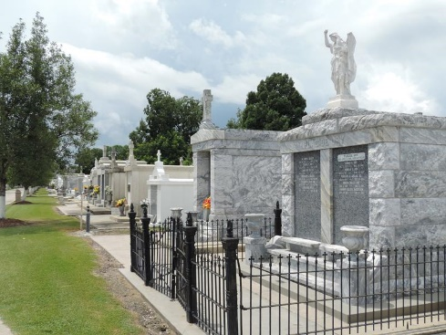

Guidry — In Garyville, La., on Sunday, August 14, 1960 at 4:45 o'clock p.m.,
ORA SCIONEAUX GUIDRY, wife of the late Edgar Guidry of Norco, La.; Mother of Mrs. Sidney Chauvin and Edwin Guidry of Norco, La. Mrs. James Amadeus, Robert, Louis and Wilkin Guidry of Dunham Springs, La.; and Morris Guidry of Lutcher, La., and the late Rene Guidry and Greta Bourgeois; also survived by 35 grandchildren and 87 great-grandchildren; aged 88 years; a resident of Garyville, La
Relatives and friends of the family are invited to attend the funeral, which will take place from Mellet funeral home, Reserve, La., on Tuesday, August 16, 1960, at 9:30 o'clock a.m., followed by Requiem High Mass at St. Hubert Church, Garyville, La., at 10 o'clock. Interment in St Peter cemetery, Reserve, La. Parlors will be open at 9 o'clock Monday morning.

The Times-Picayune, New Orleans, Louisiana
Monday, August 15, 1060, p. 2

