Lucy (Vicknair) Guillory
March 30, 1919 – July 31, 2007

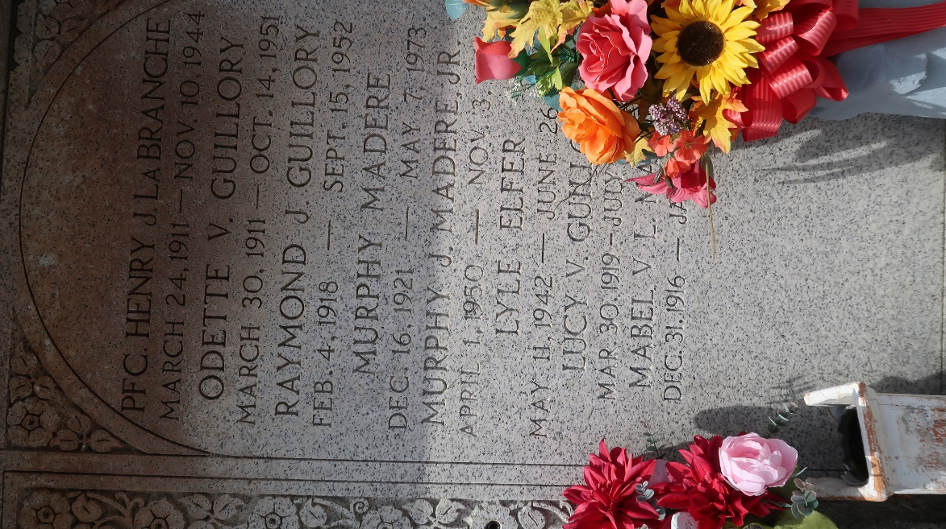

Lucy Vicknair Guillory on Tuesday, July 31, 2007 at 9:25 pm. Beloved wife of the late Raymond Joseph Guillory. Mother and mother-in-law of Jeanette and Allynn Madere, Gilda and Tommy Webre, Gwennotta and Steven Cambre, Theresa and Jerry Jolly and the late Lil Ray. Also survived by 10 grandchildren, 9 great-grandchildren and 1 great-great-grandchild. Daughter of the late Frank and Pauline Vicknair. Sister of Mabel Madere and the late Frank, Jr., Joseph and Guy Vicknair, Odette Guillory and Simone Clement. Age 88 years. A native of Laplace and a resident of Reserve for the past 42 years.
Relatives and friends are invited to attend services. Visitation at St. Peter Catholic Church, Reserve, LA. on Thursday, August 2, 2007 from 11 am to 1 pm. Followed by religious services at the church at 1 pm. Burial in St. Peter Cemetery, Reserve, La. Arrangements by Millet-Guidry Funeral Home Laplace, LA.
Times-Picayune, The (New Orleans, Louisiana)
August 2, 2007

