Odette (Vicknair) Guillory
March 30, 1911 – October 14, 1951

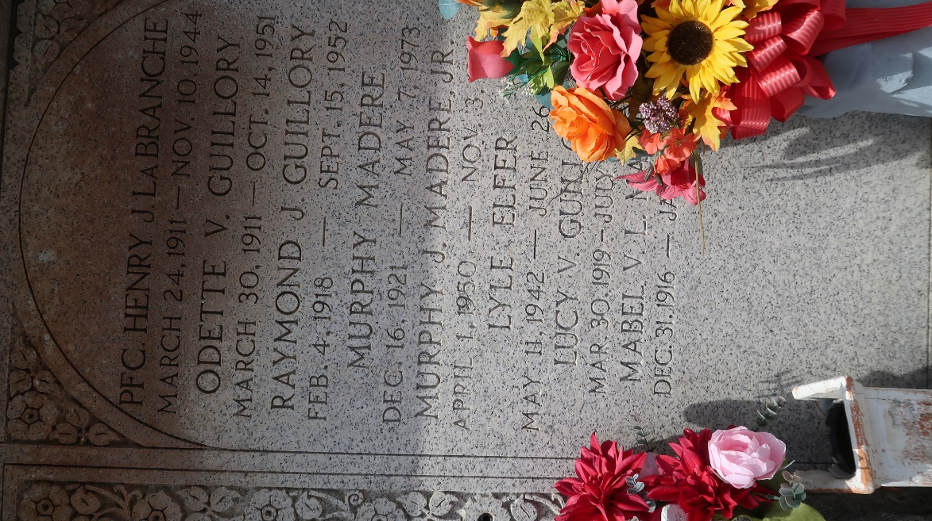

GUILLORY - On Sunday, October 14, 1951, at 4 o'clock p.m., ODETTE VICKNAIR, beloved wife of A J Guillory Sr; mother of A J Jr, Doris, Iris and Ronald Guillory; also survived by one grandchild, aged 40 years.

Relatives and friends of the family are invited to attend the funeral which will take place from her late residence, Norco, La, on Monday, October 15, 1951, at 3 o'clock p.m., followed by religious services at St Charles Borromeo church, Destrehan, La, at 3:30 o'clock p.m. Interment in St Peter Cemetery, Reserve, La. Millet funeral home, Reserve, La, in charge.
Times-Picayune, The (New Orleans, Louisiana)
October 15, 1951, p. 2

