Raymond J. Guillory
February 4, 1918 – September 15, 1952

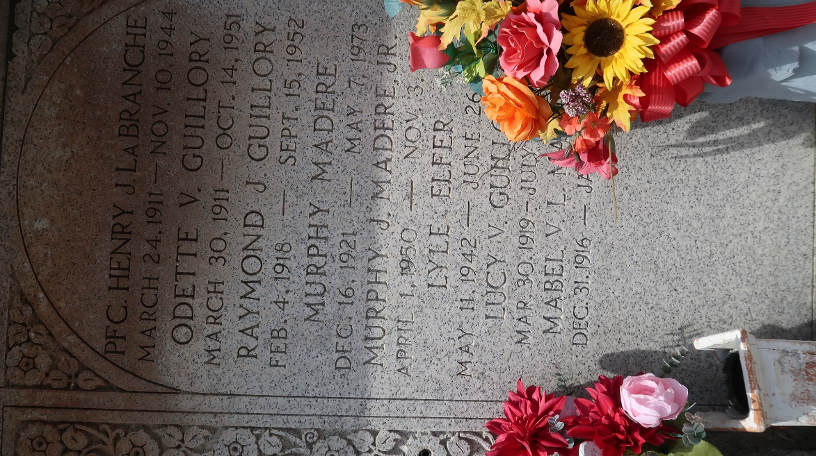

New Orleans, Louisiana, U.S., Marriage Records Index, 1831-1964

Name Raymond J Guillory
Gender Male
Marriage Date Jun 1941
Marriage Place New Orleans, Orleans, Louisiana, USA
Spouse Lucy Vicknair
**

U.S., Department of Veterans Affairs BIRLS Death File, 1850-2010

Name Raymond Joseph Guillory
Gender Male
Birth Date 4 Feb 1918
Death Date 15 Sep 1952
Cause of Death Natural
SSN xxx
Enlistment Branch NAVY
Enlistment Date 27 Sep 1943
Discharge Date 18 Oct 1945
Page number 1

