Barbara (Chapman) Guillot

July 9, 1936 – November 9, 2018

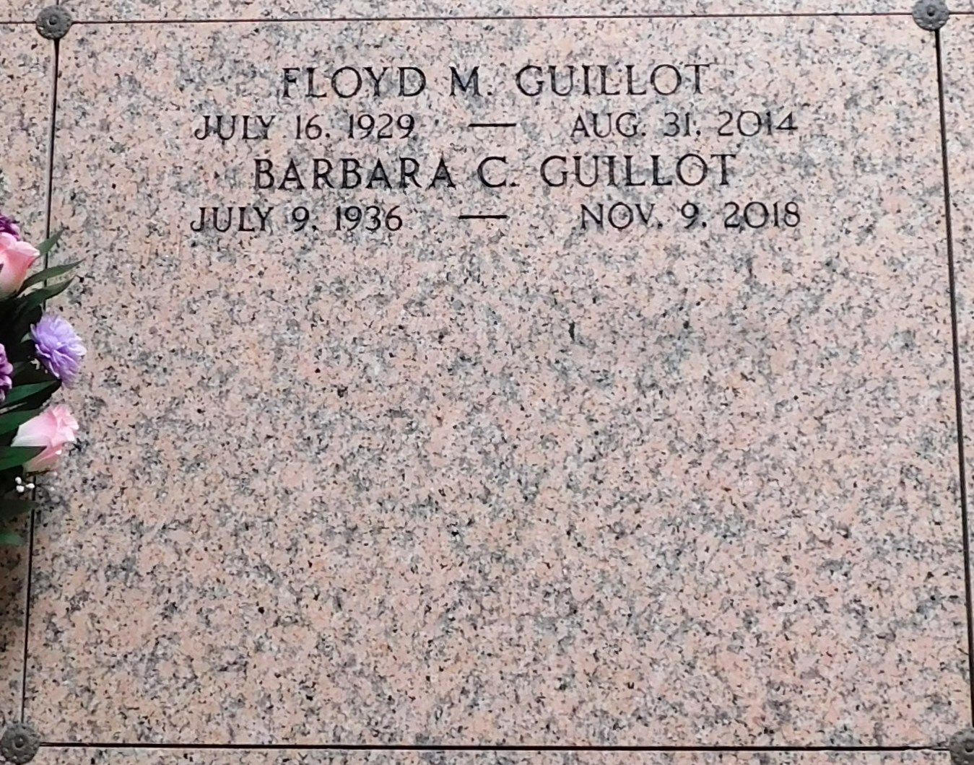

Photo by Mary Agnes Hammett

With a smile on her face, Barbara Chapman Guillot was carried home to Heaven on November 9, 2018. She was a wonderful mother and grand-mother to her very large family and leaves many cherished memories of life and love to so many.  
 She was born on July 9, 1936 in Hartsville, SC to the late Leland and LaNora Chapman. Barbara is preceded in death by her husband Floyd M. Guillot, their beloved toy poodle Missy, brothers Paul and Earl Chapman and sister LaRue Chapman. She is survived by her sister Helen Finklea, children Byron Jolley, Laura Jolley Shaw (Jeff), Carole Jolley Travers (Pat), Anne Guillot Haydel (Kenny), Jim Guillot, John Guillot (Donna), Jane Guillot Carter (Steve), grandchildren Elizabeth and John Shaw, Caroline and Jack Travers, Ashley McDonner, KJ Haydel, Mary Terrell, Jeanne Guillot, Matt and Mike Carter and 9 great grandchildren who affectionately called her "Mimi." Barbara left South Carolina as a young bride and moved to Louisiana where she raised three children with her husband Gordon Jolley.  
 She was incredibly blessed to meet and marry her second husband, Floyd Guillot, in 1982. Barbara and Floyd's home was a hub of activity for their large, blended family and friends. She shared her gifts and talents of decorating and entertaining with many while also serving in her community through her neighborhood association, church, golf club and as the director of the St. John Ministry of Care. She will be remembered for her beautiful smile, her infectious laughter and her love of life!  
 Relatives and friends are invited to attend services at Rabenhorst Funeral Home, 825 Government St., Baton Rouge, LA on Friday, November 16. Visitation is from noon to 1 pm followed by a memorial service. Burial in St. Peter Cemetery, Reserve, LA at a later date.  
 In lieu of flowers, donations can be made to The Hospice of Baton Rouge non-profit who lovingly cared for Barbara in her last days. The family would also like to thank the St. James Place Highland Court staff who loved her like their own.  
  
The New Orleans Advocate (LA)

Nov. 13 to Nov. 16, 2018