Chris Gerald Guillot

November 25, 1950 – September 1, 2014

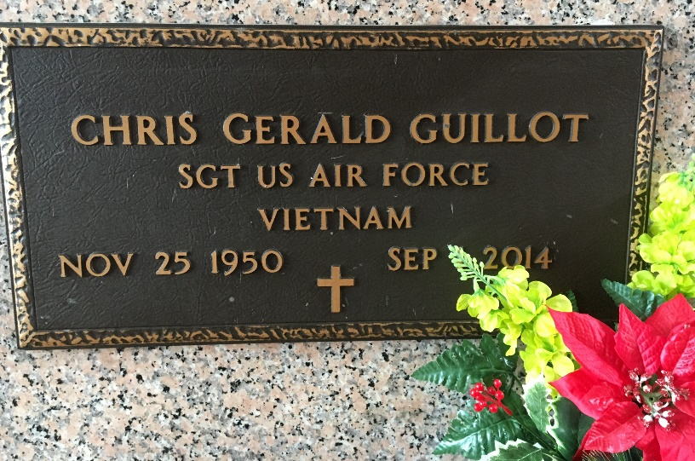

Photo by Team T-Lo

Chris Gerald Guillot, 63, was born Nov. 25, 1950, and passed away on Sept. 1, 2014. He was a native of Reserve and a resident of LaPlace.

He is survived by his wife, Maureen Hockett Guillot; his mother, Eve Simoneaux Guillot; sons Timothy Guillot and wife Lesley, Ryan Guillot and wife Debbie Jo; daughters Rebecca Guillot Graves Vance and husband Scott, Katrina Guillot, and Mary Guillot; brothers Brent Guillot and wife Sharleen, and Clyde Guillot; sister Mitzi Duplessis and husband Gene. He is also survived by five grandchildren, Shawn Guillot, Sage Guillot, Cole Guillot, Chace Guillot and Jacob Guillot. He was preceded in death by his father, Gerald Guillot.

Visitation will be on Thursday, Sept. 4, 2014, from 9:15 to 11:45 a.m. at St. Joan of Arc Catholic Church in LaPlace, followed by a Mass of Christian Burial at noon. Burial will be in St. Peter Catholic Church Cemetery in Reserve. Rose Lynn Funeral Services, 1870 Cabanose Ave. in Lutcher is in charge of the arrangements.

L’Observateur, LaPlace, Louisiana

Tuesday, September 2, 2014