Eve (Simoneaux) Guillot
June 28, 1921 – January 9, 2017

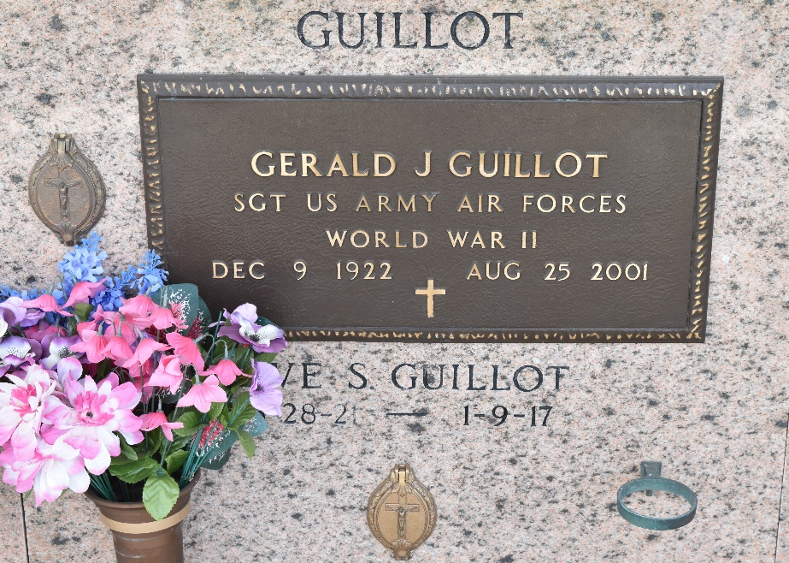

Eve Simoneaux Guillot, 95, was born on June 28, 1921, and passed away Jan. 9, 2017. She was a native of Paincourtville and a resident of Reserve.
She is survived by her children: Mitzi G. Duplessis (Gene), Brent Guillot (Sharleen), Clyde Guillot; 10 grandchildren and 11 great grandchildren. She is also survived by her sister, Eunice Levron; daughter-in-law Maureen “Mo” Guillot, as well as numerous nieces and nephews.
She was preceded in death by her husband, Gerald Guillot; her son, Chris Guillot; her parents, Leonie and Agnes Blanchard Simoneaux; and her brothers and sisters. She was a volunteer for the St. Peter thrift store for many years and a lifelong member of St. Peter’s Church.
A visitation in her honor was held Saturday, Jan. 14 at St. Peter Catholic Church in Reserve, followed by a Mass of Christian Burial. Burial was in the St. Peter’s Cemetery.
Rose Lynn Funeral Services of Lutcher was in charge of the arrangements.

L’Observateur, LaPlace, Louisiana
Thursday, March 2, 2017

