Floyd M. Guillot

July 16, 1929 – August 31, 2014

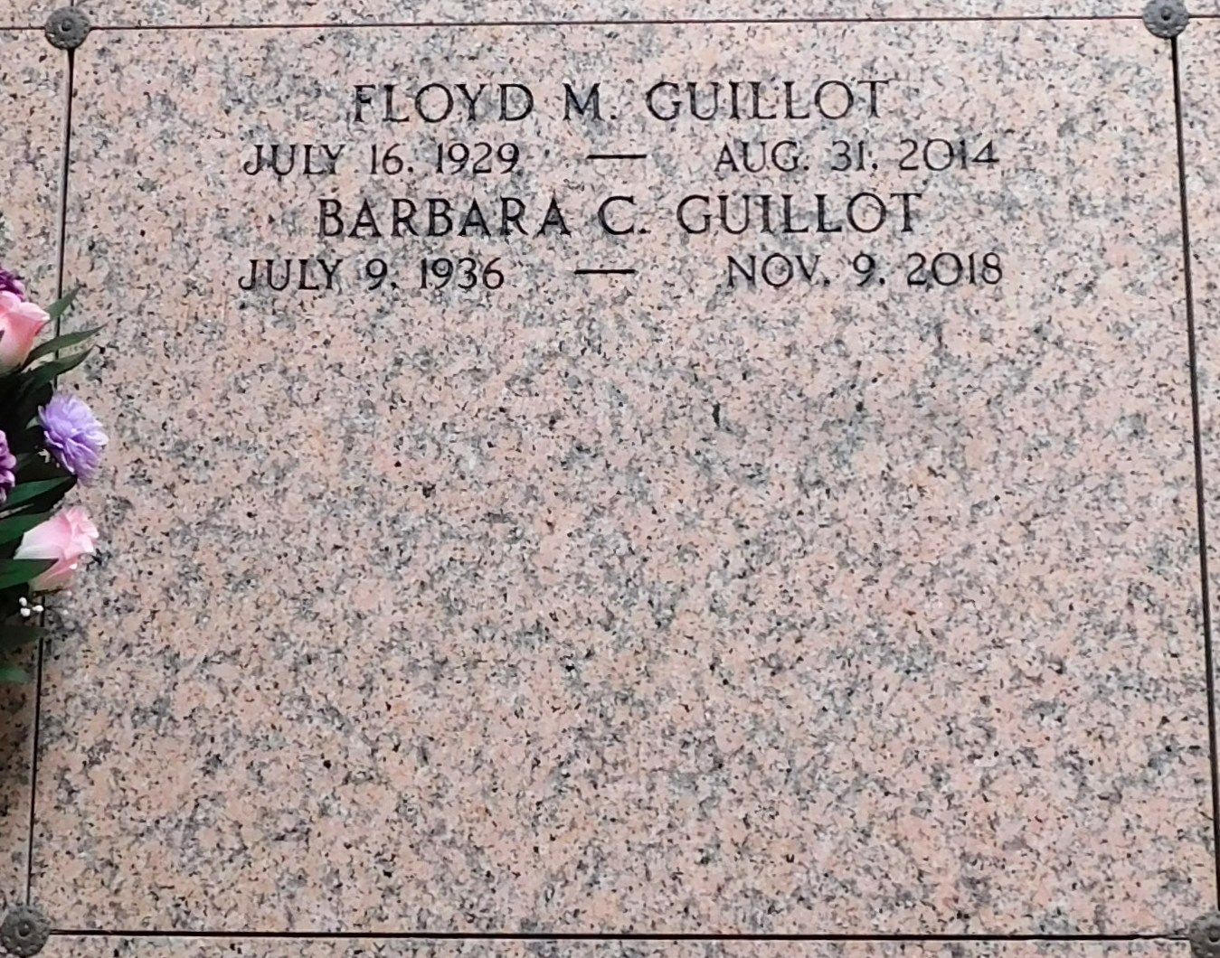

Photo by Mary Agnes Hammett

Floyd M. Guillot peacefully passed away on Sunday August 31, 2014 at home surrounded by family.  
 Beloved husband of Barbara Chapman Guillot and by first marriage of the late Catherine McCann Guillot. Father of Anne G. Haydel (Kenny), Jim Guillot, John Guillot (Donna), Jane G. Carter (Steve), Byron Jolly, Laura Jolly Shaw (Jeff), Carole Jolly Travers (Pat) and the late Mary G. Borne and Martha Guillot. Grandfather of Ashley McDonner, KJ Haydel, Mary Terrell, Jeanne Guillot, Matt and Mike Carter, Elizabeth and John Shaw, Caroline and Jack Travers also 6 great- grandchildren. Son of the late Amet and Leonie Guillot. Brother of the late Gus Guillot and Elte Carver.  
 Floyd grew up learning the value of hard work and determination and in 1986 following 39 yrs. of service he retired from Dupont. He was an active member of St. Joan of Arc Church, an avid Golfer and involved member in Riverlands Country Club. Floyd volunteered his time through the years to the United Way, ARC of LaPlace and in his earlier days he served in the LaPlace Volunteer Fire Dept. A true Southern Gentlemen, Floyd enjoyed life to the fullest and spending time with his family and friends were no exception. A devote Catholic, Floyd lived his life in an exemplary way through his love of others and through his love of God. Age 85. Born July 16, 1929 in Echo, LA and a resident of LaPlace, LA.  
 Relatives and friends are invited to attend services. Visitation at St. Joan of Arc Catholic Church, 529 W. 5th St., LaPlace, LA on Saturday September 6, 2014 from 9:30am to 11:45am, followed by Mass at 12:00noon. Burial in St. Peter Cemetery, Reserve, LA.  
 In lieu of flowers donations preferred to Magnolia School, 100 Central Ave., Jefferson, LA 70121 in honor of his son Jim. Arrangements by Millet-Guidry Funeral Home, LaPlace, LA.  
  
The Adovcate, Baton Rouge, Louisiana

Sept. 3 to Sept. 6, 2014