Gerald J. Guillot
November 9, 1922 – August 25, 2001

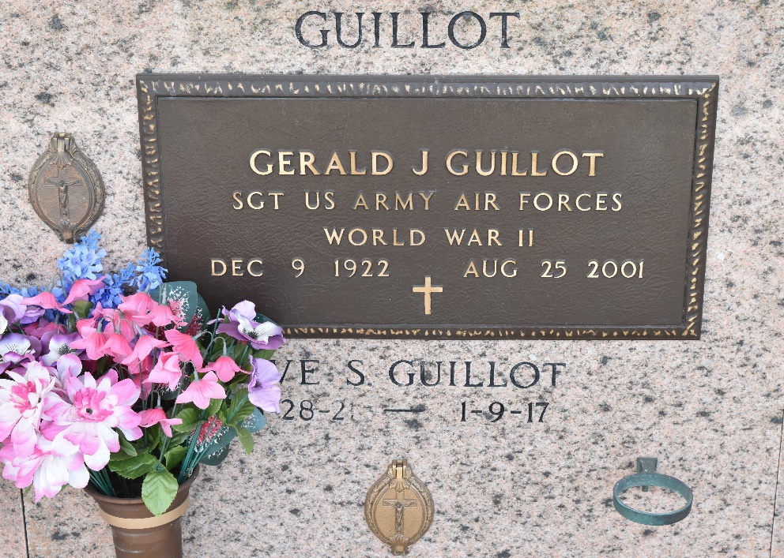

RESERVE - Gerald J. Guillot, 78, a native of Edgard, former resident of Napoleonville and resident of Reserve for 55 years, died Aug. 25.

He was the husband of Eve Simoneaux Guillot and father of Mitzi Duplessis and Chris, Brent and Clyde Guillot. He was a retired chemist at Godchaux-Henderson Sugar Refinery. He is survived by 10 grandchildren and three great-grandchildren.

Services were Aug. 28 at St. Peter Catholic Church, Reserve, with interment at the church cemetery.

L’Observateur, LaPlace, Louisiana
August 29, 2001

