James Guillot

November 16, 1954 – April 18, 2020

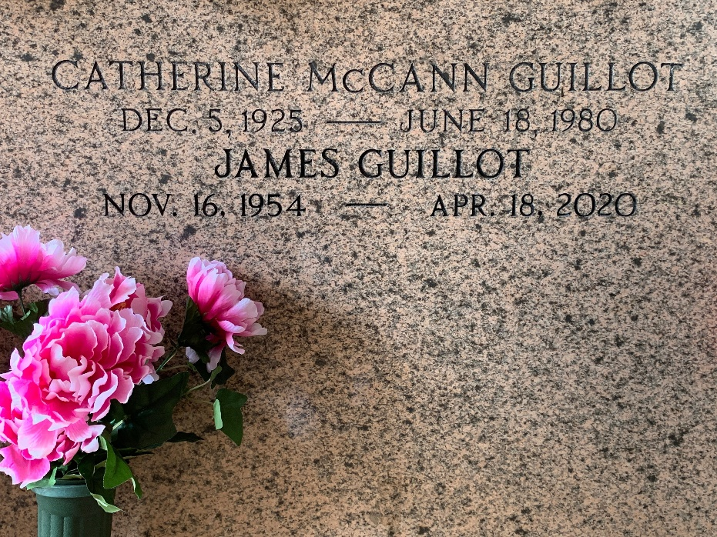

Photo by Team T-Lo

James “Jimmy” Guillot passed away peacefully on Saturday, April 18th, 2020 at the age of 65.  
 Beloved son of the late Floyd and Catherine Guillot and stepson of the late Barbara Guillot. He is also preceded in death by his sisters, Mary Guillot Borne and Martha Guillot.  
 He is survived by his siblings, John Guillot (Donna), Anne Haydel (Kenny), Jane Carter (Steve), Laura Shaw (Jeff), Carol Travers (Pat) and Byron Jolly. He is also survived by numerous nieces and nephews.  
 Jimmy was a special person as God intended and taught us a lot about people with special needs. We will miss his smile and laughter, as this was his way of communicating with us.  
 We would like to thank the entire staff of Twin Oaks Nursing Home for their support and care for Jimmy over the past few years.  
 As a result of present circumstances the funeral and committal services are private, but our community of friends are important to us.

In lieu of flowers, please make memorial donations to the charity of your choice and offer prays to all those in need.

Millet-Guidry Funeral Home, LaPlace, Louisiana