Lena (Cambre) Gurney
August 5, 1879 – December 4, 1972

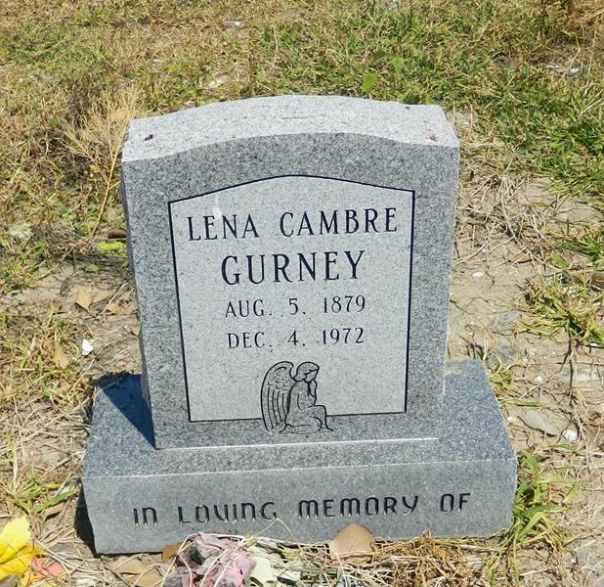

Lena Gurney - Age 92 years, a native and resident of Reserve, Louisiana.

Wife of the late P S Gurney and sister of Miss Olive Cambre of Reserve, and the late Henry, Edmond, Theophile and Elisie Cambre.

Services were Tuesday, 5 Dec 1972 at St Peter Church, Reserve, with interment in St Peter Cemetery.
The Times-Picayune, New Orleans
5 Dec 1972

