Brenda (Cambre) Hales

December 2, 1943 – March 10, 2013

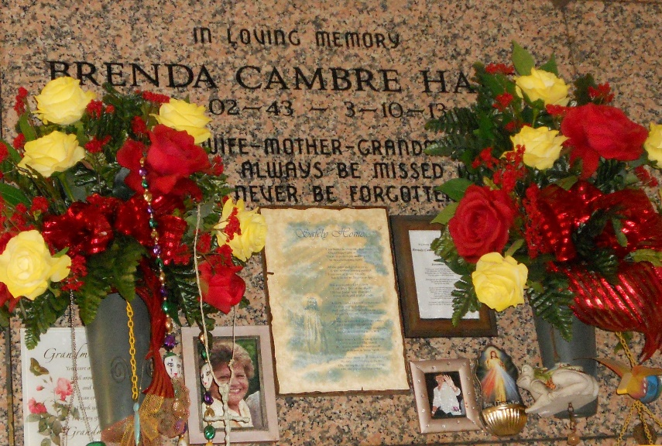

Photo by Team T-Lo

Brenda Cambre Hales, age 69, was born on December 2, 1943 and passed away on March 10, 2013. She was a native of Kenner, LA and a resident of Garyville, LA.  
 She is survived by her husband, Larry Hales; her children: Larry L. Hales, Ralph J. Hales, Mark A. Hales, Todd D. Hales, and Tanya M. Hales; her siblings: Barbara Cambre Bourgeois, Harris "Buddy" Cambre, Linda Cambre Lamondo, and Margret Cambre Deroche; nine granddaughters, two grandsons, two great-granddaughters, and three great-grandsons.  
 She was preceded in death by her father, Louis Gustave Cambre and her mother, Vivian Cambre; her granddaughter, aunts, and uncles.  
 Visitation will be on Wednesday, March 13, 2013 from 6:00 p.m. until 10:00 p.m. at Rose Lynn Funeral Services, Lutcher, LA. Visitation will resume at the funeral home on Thursday, March 14, 2013 from 8:00 a.m. until 10:45 a.m. with services at 11:00 a.m. in the funeral home chapel. Burial will be at St. Peter Cemetery in Reserve, LA.  
  
The Times-Picayune, New Orleans, Louisiana

March 11 to March 13, 2013