Carl Michael Hall
July 23, 1984 – September 23, 2008

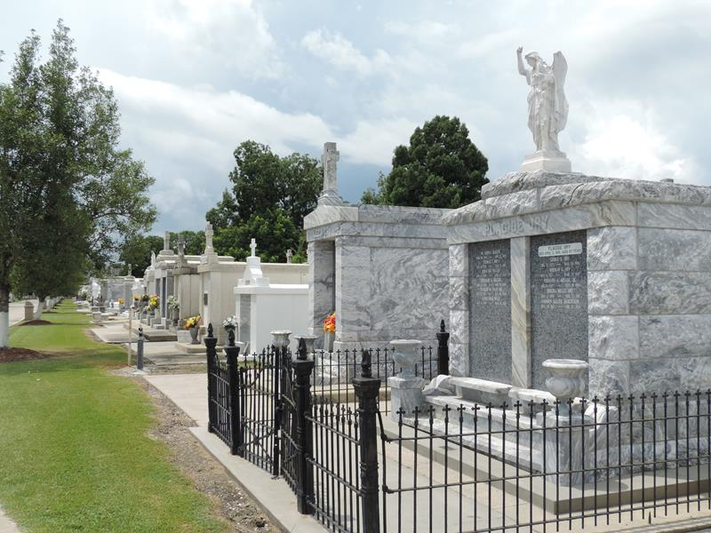

On September 23, 2008 at 9:30am Carl Michael Hall departed his earthly home.
Carl Hall, affectionately known to his family and friends as "CJ" was the youngest son born to Marie "Toni" Hall and Carl Frank. CJ was a native and resident of LaPlace, LA. and was educated in the St. John School System. He was a recent graduate of the La. State Police Training Academy. He served his community as a Sheriff Deputy.
Stepson of Debra Frank, Fiancée of Stephanie Demelo. Father of Antonio Mycel and Adrian Michael. Brother of Brandon Hall (Fabiola), and Brandi Frank. Uncle of A'Jeya, A'Jyah, and Ariana. Grandson of Ethel F. Forest, Gwen Wolfe Hall and the late Thomas Forest, Joseph Burt Hall. Great grandson of Carrie Forest, Cecile Hall, and the George Forest, Will Hall, Henry Wolfe and Lithia Wolfe. Godson of Nathaniel Hall and Gwendolyn Alexander. Age 24 years.
The Times-Picayune, New Orleans, Louisiana
September 26, 2008

