Johnelle (Williams) Hargis
February 14, 1899 - July 6, 1975
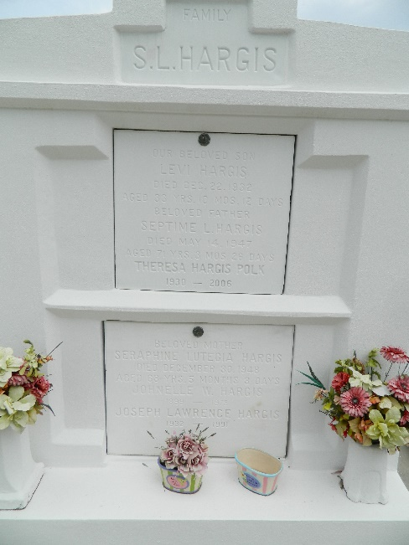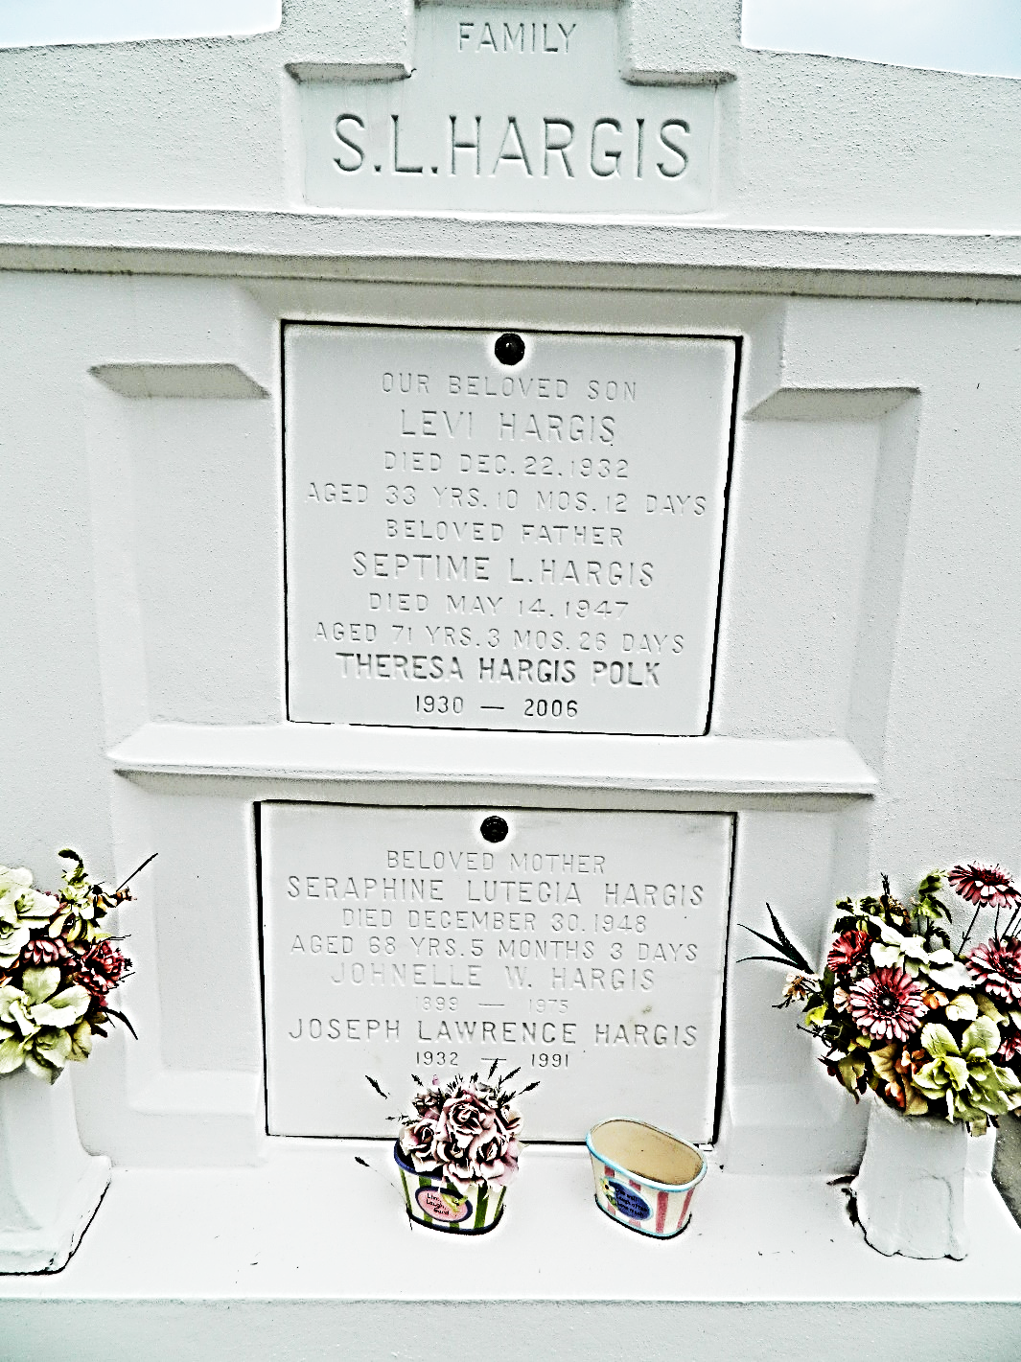

Age 76 years, a native of Lions, Louisiana, and a resident of Reserve, Louisiana.
Wife of the late Levi Hargis and mother of Joseph Hargis of Reserve and Mrs. Theresa Polk of New Orleans.
Services were Tuesday 8 Jul 1975 at St Peter Church, Reserve, with interment in St Peter Cemetery, Reserve.
Unknown source

